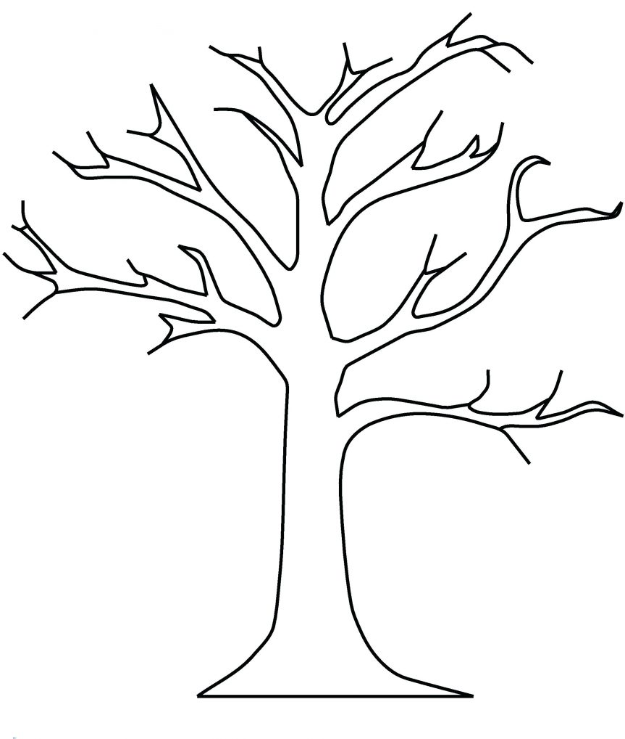

Text

Text

Text

Text

Text

Text

Text

Text

Text

Text

Text

Text

Text

Text

Text

Text

Text

Text

Text

Text

Text

**PARISH NAME**

**MINISTRY TREE**

