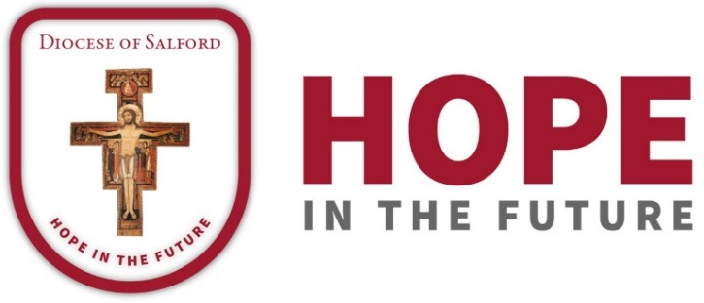

DIOCESAN PRAYER CYCLE
PRAYERS OF THE FAITHFUL

7th/8th July 2018 – 25th/26th August 2018

7th/8th July 2018
As part of our diocesan journey with Hope in the Future, we pray the parish of St Margaret Mary’s, New Moston with Fr Starkie and the Manchester Ordinariate Mission. We pray for the parish of St. Patrick, Collyhurst, and for Fr Clarke. We pray for the Presentation Sisters, the sisters of Evron and the brothers Missionaries of Charity and for the primary schools of those parishes. May God guide and inspire their missionary efforts.
14th/15th July 2018
This week in our diocesan cycle of prayer we pray for the parishes of St. Mary, the Hidden Gem, with Mgr Kay and Fr. Horne and St. Augustine’s and St. Wilfrid’s primary school. We pray for the Jesuit community at the Holy Name, Manchester with the Manchester University Chaplaincy and for the Daughters of Charity. Let us pray also for the Chaplaincy to the Manchester Hospitals. May they be a beacon of hope to the communities they serve.
21st/22nd July 2018
As we journey together in Hope as a Diocese we pray for the parishes of the English Martyrs, Whalley Range with Fr Morland SMA, and Our Lady and St.John, Chorlton, with Fr. McMahon. We pray for their primary schools, for St. Bede’s College and for an increase in the virtues of Faith, Hope and Love.
28th/29th July 2018
As a Diocese united in prayer we pray for the parishes of St Joseph’s, Mossley with Fr Lavin, and St John Southworth, Nelson with Fr Murphy. We remember all the young people and staff in their schools.
4th/5th August 2018
On our Journey with Hope we build firm foundations through our prayer for one another. This week let us pray for the parish communities of Our Lady of the Immaculate Conception, Haigh and The Holy Family, Wigan with Fr Foulkes. We pray also for St Mary’s, Oswaldtwistle with Fr O’Brien. May the Holy Spirit inspire us all to become Missionary Disciples.

11th/12th August 2018
We pray for the people of the parish of Our Lady of the Assumption, Middleton, and Canon Mullins, and for the parish of St. Mary (Our Lady Assumed into Heaven), Langho, and St. Mary, Osbaldeston, with Fr. Heakin, together with their schools and the Sisters of Charity of St Paul and the Sisters of the Cross and Passion. May they follow the example of Our Blessed Lady, the first missionary disciple.
18th/19th August 2018
In union with Bishop John, let us pray for the people of the parish of the Three Martyrs, (St. Sebastian, St. Boniface and St. Thomas of Canterbury), Salford with Fr. Macfarlane, the Spiritans and the Sisters of the Cross and Passion. We pray for the parish of St. Vincent de Paul, Norden, and Provost Brindle. May parishes and schools work closely together to build up the kingdom in their locality.
25th/26th August 2018
Let us pray for the people of the parish of Our Lady and St. Joseph, Heywood, with Fr. Daly and Fr. Deas, with their primary schools and Holy Family College, Heywood. We pray also for the people of the Good Shepherd, Colne, and Mgr. Wilkinson, with their primary schools and SS John Fisher and Thomas More College, Colne. May they be rooted in love of the Lord who has the message of eternal life.

