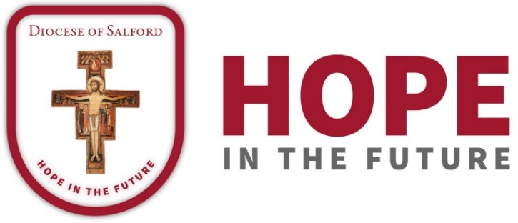

DIOCESAN PRAYER CYCLE
PRAYERS OF THE FAITHFUL

13th/14th October 2018 – 17th/18th November 2018

13th/14th October 2018

This week our Diocese prays for the parish of Christ the Redeemer, Bolton, with Fr. O’Brien, their parish priest and the parish of St. Gabriel and St. John the Baptist, Rochdale, with Fr. Johonnett, their parish priest.
We pray for the Franciscan Missionary Sisters of St. Joseph, and the Sisters of the Cross and Passion, as well as the primary schools of the parishes.
May we be filled with the love of God and rejoice in him.

20th/21st October 2018

This week let us pray for the parish of Holy Cross and St. Helen, Ashton, with Fr. Firth, their parish priest, and the parish of Our Lady and St. Alphonsus, Moss Side and Old Trafford, with Fr. Deegan, their parish priest.
We pray for the chaplaincy to Tameside General Hospital, the Sisters of St. Joseph of the Apparition, St. Damien’s High School, and the primary schools of the parishes.

As we pray for the work of Cornerstone and of the foodbanks and centres of our Diocese, may we hear afresh the Lord’s call not to be served but to serve.

27th/28th October 2018

We pray for the parish of St. James and All Souls, Salford, with Fr. Mulgrew, their parish priest, and the parish of St. Catherine of Siena, Didsbury, with Fr. Hitchen, their parish priest.
We pray for the work of the Catholic Chaplaincy to Salford University, Francis House, the Franciscan Missionaries of St Joseph and Opus Dei.
Let us pray for the primary schools of the parishes and All Hallows High School and the Barlow High School.
May our faith in the Lord Jesus give us eyes to see his presence in our world.

3rd/4th November 2018

Let us pray for the people of the parishes of St. Dunstan and St. John Vianney, Moston, with Fr. Saunders, their parish priest, and for the people of the parish of St. Edward, Lees, with Mgr Marsland and Fr. Brown. We pray for their primary schools, and for St. Matthew’s High School.
Let us remember our baptismal calling to become truly holy.

10th/11th November 2018

Let us pray for the parishes of St. Mary, Radcliffe, and St. Teresa, Little Lever, with Fr. Manock, their parish priest, and for the parish of Our Lady of Lourdes and St. Gregor the Great, Farnworth, with Fr. Kelly, their parish priest.
We pray for the chaplaincy to the Bolton Royal Hospital, for the parishes’ primary schools, and for Mount St. Joseph’s High School.
May all that we do give praise to the Lord.

17th/18th November 2018

This week we are praying for the parish of Our Lady of the Valley, Clitheroe, Dunsop Bridge and Sabden, with Mgr Corcoran, their parish priest, and for the parish of Our Lady, Haigh, and Holy Family, New Springs, with Fr. Foulkes, their parish priest.
We pray for their parish primary schools.
May our refuge and strength be in the Lord.

