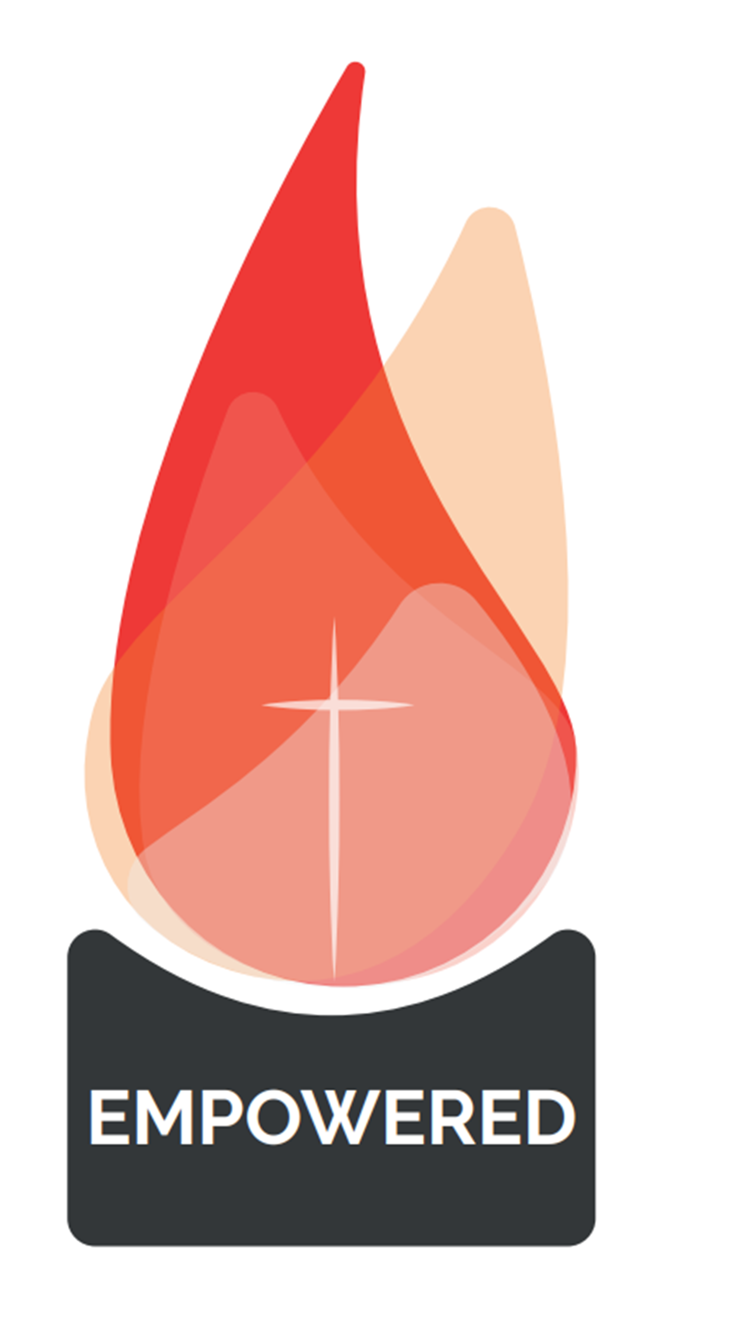

**Sign Here**

**Type Parish Name Here**

**Type Date Here**

**Type Candidates Name Here**

*“You will receive power when the Holy Spirit comes on you; and you will be my witnesses in Jerusalem, and in all Judea and Samaria, and to the ends of the earth”  
Acts 1:8*

**The Bishop, Priests and People of the Diocese of Salford rejoice with**

**who has received the  
 Sacrament of Confirmation on**

**and was marked with the seal of the   
Holy Spirit in the Parish community of**

**Celebrant**