A Guide for ‘The Big Listen’

This guide is to assist you in your role as Synod Member for ‘The Big Listen’ which is taking place between October 2023 and January 2024. Further resources will be available as we move forward on our Synodal Journey and you will be notified of these via email.

Introduction
Dear Brothers and Sisters in Christ,

Pope Francis calls us to listen to the Spirit more attentively to discern how we can better be God’s Church, given the challenges and opportunities that we face.

As the Church of Salford, in full communion with Pope Francis, we have embarked upon a more intense listening to what the Spirit is saying to the Church in our Diocese so as to discern God’s plan for our journey in the years to come.

A Diocesan Synod is a very important event in the life of a Diocese, in which the bishop, priests and lay-people come together in a spirit of prayer, to discern together, what God is asking of His Church in our Diocese. This will help us to live out our calling to be Missionary Disciples.

In convoking the Diocesan Synod, I am calling for us to be bold and creative in listening to how the Spirit may be speaking to us today in Scripture, Tradition, and in the voices of those within and beyond our Catholic community.

It is a journey by which we, clergy and laity, under the direction of the Holy Spirit, can together set out the future direction and priorities of the life and mission of our Diocese.
Thank you for your generosity in being a Synod Member for your community. With the support of the Synod Team, the Listening Sessions you will facilitate in your community, will allow for people in our parishes, schools and beyond to share what is in their hearts and minds. Through prayer and listening, we will together discern what we sense God is asking of the Church in this time and place.
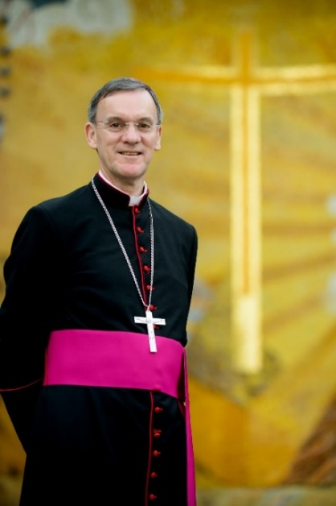
As we begin the Diocesan Synod we entrust our journey to Our Lady of Mount Carmel, Patron, with St Joseph, of our Diocese. She is the mother and first disciple of Jesus and reminds us to be attentive to the promptings of the Holy Spirit.
Never has it been more necessary, sisters and brothers, for us to call upon the Lord with that simple and most necessary prayer “Stay with us, Lord, on our Journey.”

Bishop John Arnold
President of the 38th Salford Diocesan Synod

Synod 2023—2025
The Synod Day itself will take place in early 2025 when the 400+ Synod Members will gather to discern the way ahead for our diocese. These Synod Members will include priests, deacons, religious sisters and brothers, and representatives of every parish and deanery and will reflect the rich diversity of our Diocesan community.
The two years leading up to our Synod Day in 2025 are most crucial and the participation of the whole diocese in this time of listening and discernment will determine what emerges from our Synod. The Synod Members will also have a crucial role to play in this stage of our journey.
Each parish in the Diocese has been asked to choose two members of the parish community to be their Synod Members. These Members will coordinate local listening and discernment, will keep the parish informed about the progress of the Synod, will be a local point of contact for parishioners, and will attend the Synod Day and all preparatory meetings leading up to early 2025.

Role of a Synod Member
- To lead/facilitate small discussion groups in the parish with the support of the other Synod Members and volunteers in the parish.
- Synod Members will be tasked with listening, reflecting and
discerning.
- They will be asked to find ways of listening to the concerns, needs and reflections of their communities and to ‘re-present’ these to the Synod where they will be gathered together.
- Synod Members will be called to listen to the voice of the Holy Spirit guiding the life and mission of the Church in this place and time.
- Synod Members will be asked, with their communities, to formulate the concrete proposals upon which the Synod gathering will vote in 2025.
- No prior theological knowledge or expertise is required for this role but personal commitment, preparation, prayer, being open to guidance and enthusiasm are crucial to it.
- Members must be willing and able to commit to the Synod process for a period of two years. Members will need to be present for the two Synod gatherings (please see roadmap on page 6), to facilitate two/three local listening sessions and attend training sessions.

Our Commitment to you
The role of Synod Member should be uplifting, inspiring, and rewarding but it will also be a demanding and busy task. The Synod Office is here to support you every step of the way and, in particular, we promise:

- Full training in the art of listening, discernment, and an overview of the Synodal journey will be provided. (Advice on Safeguarding considerations is being provided by the Diocesan Safeguarding Team but please also consult your Parish Safeguarding Officer about any arrangements you are making for The Big Listen and any subsequent synodal listening meetings.)

- Ongoing formation and training throughout the journey at the various stages.
- We will provide resources at each stage of the journey. These are available on the Synod webpage (www.dioceseofsalford.org.uk/faith/synod/) in the ‘Resources’ drop down section towards the bottom of the page. Resources will also be sent out by email. If you require any resources, please email synod@dioceseofsalford.org.uk.

- We will provide access to the Synod Members Portal.

- Support and guidance available from the Synod Team.

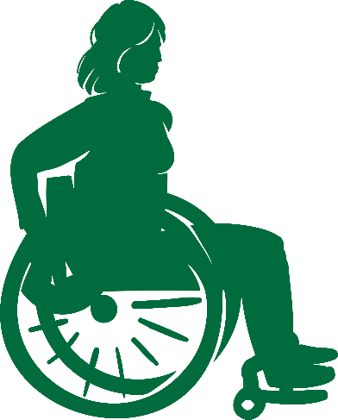

The Vision of our Diocesan Synod
A Diocesan Synod is an opportunity for the bishop, priests and lay-people of our diocese to come together in a spirit of prayer, discerning what God is asking of His Church in our Diocese and how we can live out our calling to be Missionary Disciples.
The Vision of our Diocesan Synod is:
- To enable true collaboration between the clergy and laity at diocesan and parish level by truly listening to each other.
- To discern what the Holy Spirit is saying to the Church in Salford at this next stage of our journey.

“The purpose of the Synod is not to produce documents,
but to plant dreams, draw forth prophecies and visions,
allow hope to flourish, inspire trust,
bind up wounds,
weave together relationships,
awaken a dawn of new hope,
learn from one another,
and create a bright resourcefulness,
that will enlighten minds,
warm hearts,
give strength to our hands.”

Pope Francis

Pope Francis words at the opening of the Synodal Path…
“Celebrating a Synod means walking the same road, walking together”

We are called to Encounter, listen, discern.
As facilitators for the synod groups in your parish, or deanery, your role will be to enable this to take place. Listening, is the greatest gift you can bring to this role and encourage among those who attend.

Our Synodal Journey
N.B. This ‘Roadmap’ is subject to changes.
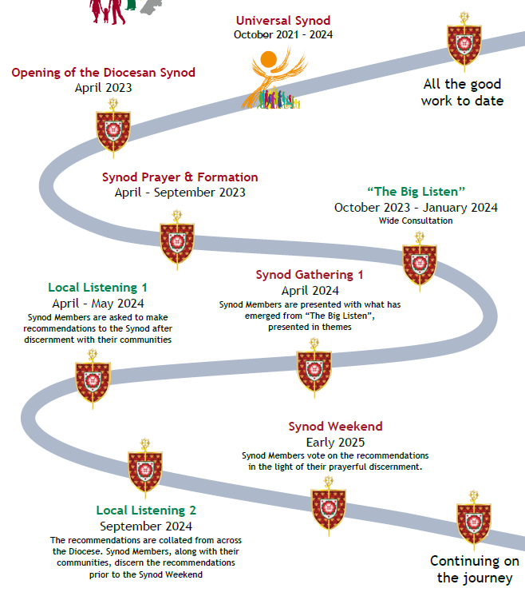

The following pages offer guidance on:

‘The Big Listen’: Structure and practicalities for Parish Synodal Listening Meetings

‘The Big Listen’ Session - BEFORE

BEFORE: Things to consider
- Where and how you will advertise your parish’s Big Listen session/s. What information do you need to include? You may need to give the same message in several different ways to capture as many people as possible.
- Consider personally inviting people who might need a little bit of encouragement.
- Reach out to invite, e.g: young people; newly married; engaged and preparing for marriage; parents of recently baptized children; parents of children on Sacramental Programme; RCIA.
- Reach out to people who are not active in your parish and local neighbourhood – be brave! Think about how you can capture their input.

Accessibility: Think about how you can remove barriers for…
- Special interest groups;
- Young people Under 18;
- Particular needs e.g., Deaf Community;
- People with Special educational needs and disabilities (SEND);
- People on the margins of our communities;
- People with English as a second language (ESL).

If you require advice or support, please email synod@dioceseofsalford.org.uk and we will assist as best we can.
One of the measures of our Diocesan Synod will be how accessible it is to all.

BEFORE: suggested checklist
- Set a date and time for the meeting/s.
- Book a suitable room.
- Whose help do you need? Now? On the day?
- Any accessibility considerations and adjustments?
- Discuss your plans with your Parish Safeguarding Rep to account for any Safeguarding considerations.
- What materials and equipment do you need? Is it in working order?
- How long will your meeting/s need to be?
- Will you be serving refreshments beforehand? Who will help?
- Decide on your registration procedure (optional) – sign in sheets for registered/people arriving on the day so you know how many attendees there are for fire regulations.
- Do you need laptop, screen, projector, sound?
- Decide on what talking piece items you will use (see later).
- Prepare a timetable/schedule for the meeting/s.
- If possible, send out information about what to expect in advance to those who have registered.
Table leaders
You will need to assign a leader for each table. Ideally this will be done in advance once you know who has registered. Try to ask individuals who:

- Can create a welcoming and prayerful atmosphere.
- Can lead without dominating.
- Has the ability to encourage others to contribute.
- Can keep individuals on task.

If possible, brief your table leaders on their role in advance of the meeting/s.

Setting up just before
- Arrange room into small groups (max 8 per group) sitting in circles if possible.
- Confirm who your Table Leaders are and brief them on how to lead each small group.
- Set up laptop and screen etc if you are using them.
- Ensure you have a copy of the Synod Questions ready (These will be sent out via email before the start of ‘The Big Listen’).
- Create a prayerful setting, e.g. a focal table at the front with a cloth, candle, Icon, crucifix, scripture passage open etc.
- You might want appropriate background music as people are entering the meeting room.
- Name badges/labels and sign in sheets (you will need everyone to sign in for health and safety reasons).

Provide each table with:

- A candle (artificial is fine, if using a real candle please don’t leave unattended).
- A talking piece for each table. (This may be a pebble, a holding cross, a 1-decade rosary, an artificial candle etc something comfortably held in your hand, and then passed to the next person once the current speaker has finished.
- Post it notes/pieces of card – a different colour for each of the questions and pens for each table.
- A set of numbered envelopes, one for each question for each table, to collect the corresponding post-it notes/cards.

‘The Big Listen’ Session - DURING
DURING: How to conduct The Big Listen on the day
- Ask attendees to sign in.
- Introduce yourself, welcome everyone and thank them for coming.
- Share important housekeeping information e.g., location of toilets; fire exits etc.
- Begin with an opening prayer or reflection provided or one of your choice.
- Explain the structure of the meeting and what the process will be.
- Share an uplifting Statement of Purpose with the attendees about why you have gathered.

E.g.: This is an opportunity to let the Holy Spirit work through us. It is an exciting and challenging opportunity for us all. A moment in history for the laity to have our voices heard and help shape the Diocese. To be part of the fulfilment of Pope Francis dream: “to reach out and see the world through a different lens and reach out to those people on the peripheries.”

You might want to remind people what a Diocesan Synod is and what it isn’t.

Explain the Ground Rules:

NB: Synodal listening isn’t about having a conversation, discussion or replying directly to what the previous person has just said. It is about each of us being open to the Holy Spirit, with one person speaking at a time in personal response to the question that has been asked.

- When you are speaking, please express your personal response.
- The only person you can truly speak for is yourself.
- Use ‘I’ language and take ownership of what you say.
- Speak from your heart.

Suspend status
- Everyone present is an equal partner in the synod process.
- Everyone is an expert in their own life and that is what you will bring to the dialogue.

Honour confidentiality
- Ask participants to commit to not repeating the private comments of others beyond the meeting. (Note for Synod Members: Any contributions which have Safeguarding implications must be directed to your Parish Safeguarding Representative asap).
- In your follow-up work, do not assign particular comments after the meeting to the individuals who said them.

Only one person speaks at a time.
- Everyone has the opportunity to speak for 60 seconds (approx.) when you are in possession of the talking piece.
- If you do not wish to speak when the talking piece is passed to you, simply pass it on politely to the person next to you.

DURING - Principles of Group Listening Sessions

- Invite attendees to join a group between 4 and 8 led by a Table Leader who will explain these principles and the methodology (a guide sheet will be provided).
- Only the person holding the talking piece is allowed to speak.
- Once they have finished speaking (max 60 seconds), they pass it to the person next to them.
- This procedure is repeated until every group member has spoken, once only.
- Each person shares, in turn, from his or her own experience.
- Each of the other group members honour what is shared by receiving it in silence and without comment.
- Group members may choose to accept the talking piece but simply hold it without speaking.
- The group has finished when each person has had the opportunity to share.
- The Table Leader is responsible for ensuring that each person has time to share.
Each person accepts responsibility for the depth and detail of their own sharing.

Creating time for prayer:

NB: This time is very important as it sets the scene for listening in the presence of the Holy Spirit.
This is Holy Ground, a place where God is present in each person. The candle is lit in the centre of each table.
The opening prayer takes place. Suggested prayers to open and close are provided at the back of this guide.
Each person in the circle/at each table is encouraged to look at the others as if seeing them for the first time, then in silence acknowledge their presence.

Methodology of Group Listening
- One Synod Member introduces the session, principles and methodology to the whole group and leads the time of prayer. The Table Leaders check everyone understands, is in agreement and is ready.
- One Synod Member reads out Synod question 1.
- Table Leaders establish and agree the first person to speak in their group and invite them to respond to Synod Question 1 for up to 60 seconds. They will then pass on the talking piece to the next person in a clockwise direction.
- The next person speaks and the same process continues until everyone in the group has shared a response to the current question (people may choose not to respond and that is to be respected. They will respectfully pass the talking piece to the next person).
- One Synod Member invites the group to reflect in silence on what they have heard for one minute and then to write down one thing which struck them most from the sharing (either what they said or what someone else said) on a coloured post-it. (Table leaders will let the group know which colour of post-it note corresponds to which question. You may wish to write it on the envelopes in advance).
- The post-its are collected by the Table Leader and placed in the appropriate envelope.
- The process is repeated for Synod Questions 2, 3 and 4 collecting the post-its following each question. One Synod Member is responsible for the time keeping and reading out the question to the whole group. The Table Leader may repeat the question for their small group.
- At the end of the listening session, the Table Leaders hand the post-its in their relevant envelopes to the Synod Member.

‘The Big Listen’ Session - AFTER
AFTER: What happens at the end of the meeting?
Thank everyone for coming and taking part in such an important process for the future of our diocese/Church in our local area. Explain that Pope Francis is inviting us to use this synodal listening approach to all aspects of parish life.
Explain that after all the information has been collated, there will be a Synod Gathering in April 2024 for all the Parish Synod Members, who will keep parishioners posted.
Invite everyone to follow the latest synod news on the diocesan synod webpage - www.dioceseofsalford.org.uk/faith/synod.
The meeting can be concluded with the Closing Prayer (at the back of this guide).

What do Parish Synod Members do after the meeting?
What happens to what people wrote on the post-its?
The Parish Synod Members will send the content of all the post-it notes to the Diocese either by uploading them to the Members Portal or by typing them onto the 'Listening Record’ form, which will be sent to Members by email at the start of October 2023. If this is not possible, they can be sent in the post to the address on the back of this guide. These must be sent in by Friday 19th January 2024 at the latest, but as soon as possible is preferred.

Information: Decide what information you want to share with your parish about the meetings you have hosted.
Next Stage: Prepare for the next stage of our Diocesan Synodal Journey.
Keep it alive: Keep our Diocesan Synod in your parish’s thoughts and prayers.
Discern: how you can start to use synodal listening in other aspects of parish life.
Conclusion
Synod Members and attendees of the Listening Sessions are encouraged to have a similar conversation, using the same questions, with their family and friends. Additional submissions in response to the ‘Big Listen’ questions by individuals can be sent in via the form on the Synod webpage. We are all encouraged to reach out to people who are not active in our parishes and neighbourhoods. BE BRAVE! Invite people to join in the BIG LISTEN.
Synod Members are asked to remind the participants in every group about the next stage on this Journey. They may wish to share that after all the information is collated, there will be a Synod Gathering in April 2024 for all Synod Members and following this there will be further opportunities for local listening and discernment sessions.
There will be Diocesan initiatives taking place and we will be working closely with our Youth and Education Teams to ensure synodal conversations take place in our schools and colleges. An online form will also be open for anyone who wishes to make a contribution to our Synod, so please signpost people to this as appropriate.

“Our shared mission as Christians is to bear joyful witness wherever we find ourselves, through our actions and words, to the experience of being with Jesus and members of his community, which is the Church. That mission finds expression in works of material and spiritual mercy, in a welcoming and gentle way of life that reflects closeness, compassion and tenderness, in contrast to the culture of waste and indifference. By being a neighbour, like the Good Samaritan (cf. Lk 10:25-37), we come to understand the heart of our Christian vocation: to imitate Jesus Christ, who came to serve, not to be served” (cf. Mk 10:45).
Pope Francis

Synod Members’ Portal

The Synod Portal has been developed to allow you to input the responses from your Listening Sessions.
- To access the Portal, visit www.dioceseofsalford.org.uk/faith/synod/ and scroll down the page until you find a window similar to the image below.

- Each time you wish to access the ‘Members’ area’ of the Portal, you will need to enter the email address registered with the Synod office. This is to ensure only Synod Members can access the Portal and removes the need to remember usernames and passwords. After entering your email and clicking ‘Send Login Link’, please go to your emails and find the link sent from help@synod2025.co.uk (you may need to check your spam/junk box). Clicking this link will take you to your account on the Synod Portal.

- An email will also be sent from help@synod2025.co.uk at the start of September which will contain a link to set up your account on the Synod Portal (you may need to check your spam/junk box).

- If you have any technical difficulties, please email help@synod2025.co.uk. For any other questions, please email synod@dioceseofsalford.org.uk or call 0161 817 2214.

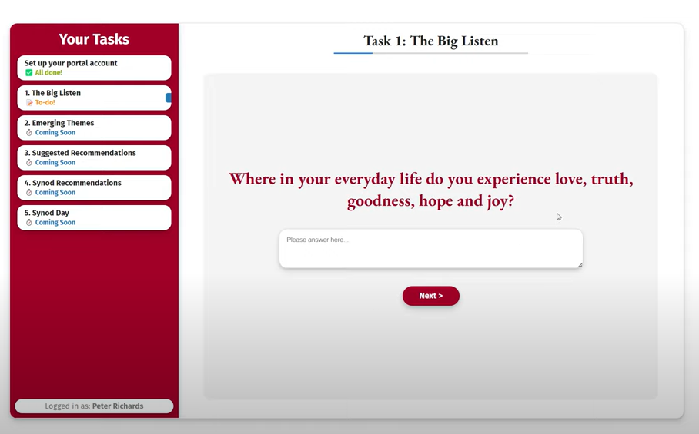

Opening Prayer for Meetings
Further prayer resources and printable service sheets will be produced and will be sent via email before ‘The Big Listen’.

Opening Hymn
Spirit of the Living God, fall afresh on me.
Spirit of the Living God, fall afresh on me.
Melt me, mould me, fill me, use me.
Spirit of the Living God, fall afresh on me.
Spirit of the Living God, fall afresh on us…

Scripture Reading: Gospel of St John 14:15-17, 25-26

If you love me, you will keep my commandments. I shall ask the Father, and he will give you another Advocate to be with you for ever, that Spirit of truth whom the world can never receive since it neither sees nor knows him; but you know him, because he is with you, he is in you. If anyone loves me, they will keep my word and my Father will love them, and we shall come to them and make our home with them. I have said these things while still with you, but the Advocate, the Holy Spirit, whom my Father will send in my name, will teach you everything and remind you of all I have said.

Pause to reflect quietly.

The Synodal Path: is Communion, Participation, and Mission.
Pope Francis said: “Celebrating a Synod means walking the same road, walking together. Let us look at Jesus. First Jesus encounters a rich young man on the road. Jesus is, completely present to the person, open to encounter. He listens with his heart to what the person has to say.

How good is the hearing of our heart?

Encounter and listening are not ends in themselves, leaving everything as it was before. Jesus calls us to empty ourselves, including, our inward looking and worn-out models, of care for others.
To ask ourselves what is it that God wants to say to us in this time? What is “the direction in which he wants to lead us?
Let us have a good journey together, encounter, listen, discern. Even as we seek the Lord, he always comes with his love to meet us first”. (Opening of the Synodal Path St Peter’s Basilica 10th Oct 2021)
Pause to reflect quietly on the words of Pope Francis.
Lord as we prepare to begin our meeting, we recall your promise to be present when two or three are gathered in your name.
We know that without you here among us, and within each one of us, we will labour in vain. R/ Unite us, Lord in your Spirit.
We rejoice that we are called together to work in your name. Inspire us with your Spirit of wisdom, plant seeds of your vision within our hearts and minds. R/

Give us humour and humility in our working with one another, so that we may know the privilege of participating in the coming of your Kingdom. R/

We ask that working together will increase the communion among us and give us new courage in all that we do for you. R/

Grant us the willingness to be open to each other, to respect and listen, to be honest and supportive of each other for the sake of your Kingdom. R/

Pause to reflect quietly.
Let us pray:
Lord may the true business of this meeting be our spiritual transformation, and the transformation of others through us and not simply the accomplishment of tasks. We ask this of you in the name of the Father and of the Son and of the Holy Spirit. Amen.
(Adapted from a prayer by Edward Hays. Prayers for the Servants of God.)

Closing Prayer for Meetings

Take a minute to quietly reflect on all you have heard at the meeting.
Lord, we thank you for the insights you have given us during this meeting. May we ponder them in our hearts in the days and weeks to come. Bless the people who have shared with us.
Synod Prayer: Said together:
Loving Father, be with us as we seek new ways of being your people in our Diocese. May each new day bring us closer to your son Jesus, as we follow his teaching and become disciples of love. As we continue our Synodal journey, draw us closer to each other. May the truth of your Spirit enlighten us. Open our hearts, as we listen to each other and reach out in love to your people. Stay with us, Lord, on our journey. Amen
Our Lady of Mount Carmel, pray for us.
St Joseph, pray for us.

Synod, Cathedral Centre, 3 Ford Street, Salford, M3 6DP
T: 0161 817 2214
E: synod@dioceseofsalford.org.uk
W: www.dioceseofsalford.org.uk/faith/synod

