

Cathedral Centre 3 Ford Street Salford
M3 6DP
Required for September 2024
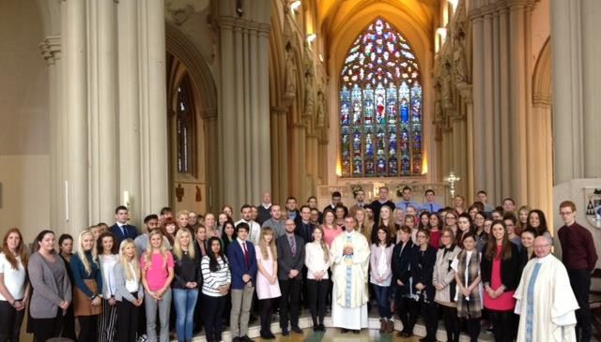

ECT Primary Pool 2024

The Primary Pool will identify and recommend high quality candidates who will gain QTS in summer 2024, for interview to Catholic schools with vacancies for September 2024.
We are looking for excellent ECT’s who are:
- able to inspire and motivate by providing high quality teaching and learning
- enthusiastic and creative
- keen to contribute and support the Catholic ethos of the school
- committed to the safeguarding and wellbeing of children

The Application Form, Person Specification and Job Description can be found in Vacancies on the Diocesan Resource Centre here.

Completed application forms are to be returned to the
Department for Education at the above address or emailed to education@dioceseofsalford.org.uk by 12:00 pm on Friday 17th February 2024.

Shortlisting will take place w/c Thursday 26th February 2024, with interviews taking place w/c Monday 11th March 2024.

Further enquiries should be made to 0161 817 2204

