Where can I find more information?
More information, along with an expression of interest form can be found on the Diocese website:
www.dioceseofsalford.org.uk/services/education
Or you may contact:
Lauren Cumbo
Department of Education
Cathedral Centre
3 Ford Street
Salford
M3 6DP

Telephone:
0161 817 2204

Email: education@dioceseofsalford.org.uk

A Message from the Bishop

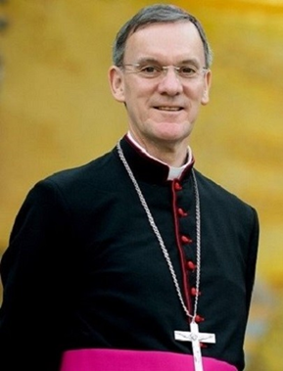
Our Catholic Schools are rightly praised as being “excellent” by the Department for Education, Local Authorities, parents and others. There are many reasons for this but I believe that the foundation for our schools’ success lies in ensuring that Jesus Christ is at the centre of all our endeavours. This is the single most important reason why our schools are caring environments where every effort is made to provide the best possible education for our children.

Another reason for the success of our schools is, of course, the dedicated work of our staff and governors. A majority of our governors are Foundation Governors who are appointed by me, through our Department for Education. We are always searching for committed Catholics who are willing to give of their time and expertise for this important work for Christ in our Diocese.
I would like to encourage you to think about putting your faith, your gifts and some of your time at the service of our schools as a Foundation Governor. Could this be a way in which you might work as a missionary disciple for Christ in our Diocese? Please consider this possibility as a way in which you may help in building our Church for the future, by providing the best possible education for our young people. Thank you.

Could you be a School Governor?

Governing a Catholic School in the Diocese of Salford

Could you be a School Governor?  Are you:  - A practising Catholic?  - Interested in the education of young people?  - Passionate about Catholic education and its vital role in advancing the mission of the Church?  - Prepared to work as part of a team responsible for the strategic direction of one of our Catholic Schools?  - Sufficiently skilled and able to share in the leadership of a school or college?  You might consider becoming a foundation governor in a Catholic School.  Governors can have a diverse range of skills and background. You will need the skills to work as part of a team, to listen, to ask challenging questions and to help make collective decisions to serve the best strategic interests of the school.  Training is available and governors can have a diverse range of skills and background. | Who is on the Governing Board?  Where a school is maintained by a local authority, the governing body will be composed of parents elected by the parent body, a representative of the local authority, a member of staff elected by the staff of the school and the Headteacher. In a Catholic maintained school, these governors are joined by a number (usually seven) of foundation governors, who are appointed by the Bishop.  There are 208 schools in the Diocese of Salford, accommodating approximately 65,000 pupils. In total approximately 1,500 foundation governors. At any one time, there are approximately 150 vacancies, some of which are difficult to fill. We particularly welcome, therefore, applications from potential governors who are prepared to give service in localities other than their own.  Nominees would not be expected to have a direct knowledge of current education law, of School organisation or Governance but should be willing to learn and dedicate reasonable time to their responsibilities. They would be expected to have a genuine commitment to the educational, personal and spiritual development of students and in particular to the wellbeing of the school community as a whole. Appropriate training opportunities will be made available. Appointments are made for a four-year term of office. | What does a School Governor do?  All governors have the responsibility upholding the distinctive ethos of a Catholic school. Foundation governors have the further duty of assisting the Bishop in his role as first teacher and leader of the diocese.  In addition, governors have the responsibility for:  - Oversight of the teaching of RE and Collective Worship  - The admission of pupils  - The appointment of staff  - Oversight of the curriculum  - Oversight of finance  - Setting the aims and objectives for the school  - Monitor and evaluate the progress the school towards achievement  - Be a source of challenge and support to the Headteacher  Most governors will attend full governing board meetings (normally 3 or 4 a year) and additional committee meetings.

