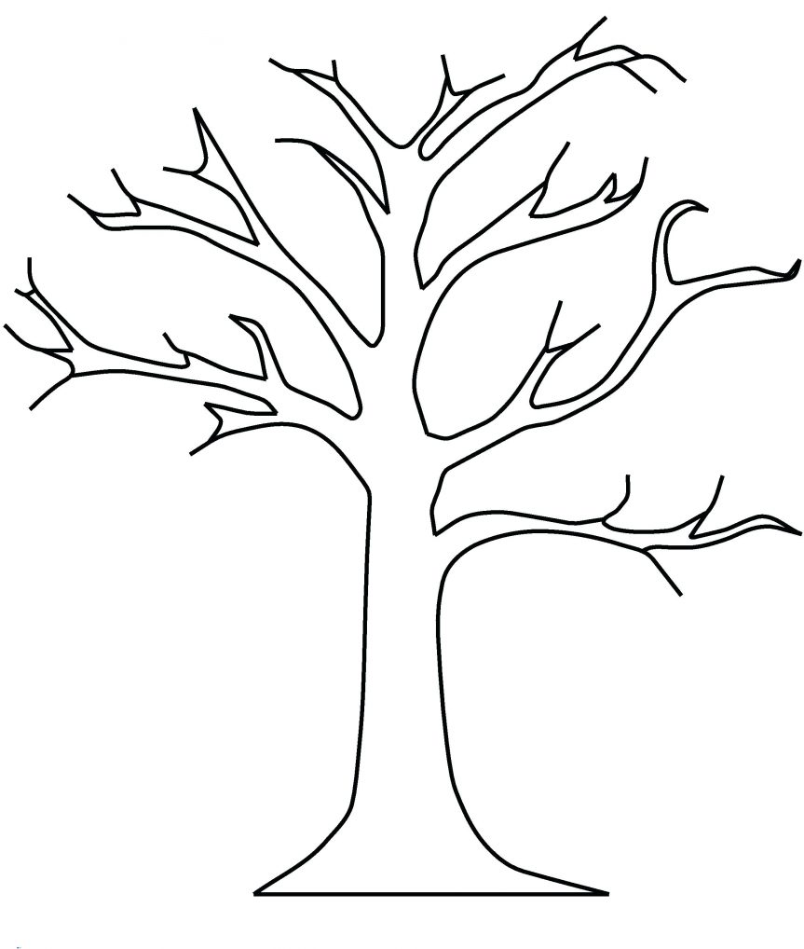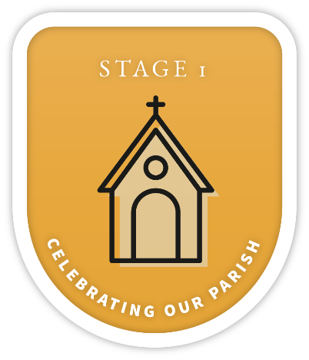

Text

Text

Text

Text

Text

Text

Text

Text

Text

Text

Text

Text



**PARISH NAME**

**MINISTRY TREE**