A PRAYER FOR

OUR COMMON HOME
All powerful God,
you created all things, and you are present throughout the universe
and in every creature,
You embrace with your tender love all that exists.
Pour out upon us the power of your love,
so that we may have the strength and courage
to protect all life and the beauty of our world,
preserving it from pollution and destruction.
Fill us with your peace, that we may live
as brothers and sisters, harming no one,
And caring for the Earth, our common home.
Teach us to discover the worth of every creature on this earth,
Let us protect those at risk and in danger,
Encourage us as we seek justice, love and peace.
Stay with us each day, with the power of your grace.

Through Christ our Lord
Amen

A PRAYER FOR OUR COMMON HOME
All powerful God,
you created all things, and you are present throughout the universe
and in every creature,
You embrace with your tender love all that exists.
Pour out upon us the power of your love,
so that we may have the strength and courage
to protect all life and the beauty of our world,
preserving it from pollution and destruction.
Fill us with your peace, that we may live
as brothers and sisters, harming no one,
And caring for the Earth, our common home.
Teach us to discover the worth of every creature on this earth,
Let us protect those at risk and in danger,
Encourage us as we seek justice, love and peace.
Stay with us each day, with the power of your grace.

Through Christ our Lord
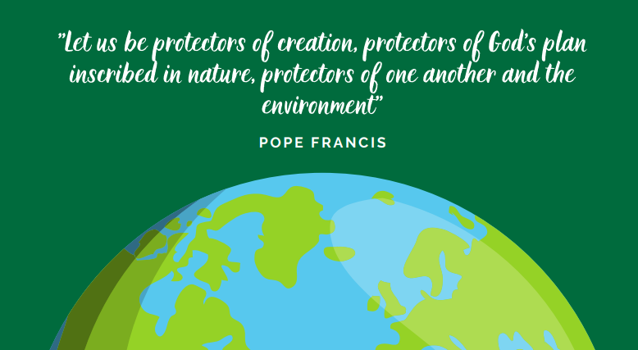
Amen

