MISSION ACTION PLAN

Parish: Deanery:

Timeframe of plan (e.g. 3 years):

A good place to start is with the ‘parish review’. This should be completed by the Hope in the Future/Shared Leadership team. This will help you to see where you are currently and see any gaps in groups in ministries so you can plan to where you want to be.
If you have any questions or would like any support please contact John Griffin (Hope in the Future Programme Coordinator) by emailing john.griffin@dioceseofsalford.org.uk or calling 0161 817 2222 (ext. 246). Feel free to send your completed Mission Action Plan to the email address above.

Our Vision/Values/Mission Statement (you may want to use the supporting resource on writing mission statements)

Stage 1 - Review

Where we are starting from - a realistic summary of our context and our present situation. You may wish to use the answers to the ‘parish review’ as a starting point.
Where we are going - a description of where we would like to be in five years’ time. It is important to listen to what God is asking of us, to one another and to feedback and ideas from a representation of the parish

Stage 2 - Prioritise

How we will get there - a description of the priority actions if we are to ‘get there’.
Priority 1

Priority 2

Priority 3

Priority 4

Stage 3 – Current activity plan.
What do we need to do and by when? Precise, time-based and measurable actions that help us achieve our priorities. It is assumed that this page will be updated regularly as the outworking of the plan develops and progresses.
Task / objective | Person Assigned | Resources available/required | Budget required | Timeline (expected start and completion dates) | Review method and timing
1.
1.
1.
2.
2.
3.
3.
4.
4.
4.

Our partners – what other people do we need to involve/consult – e.g Diocesan support staff; other churches; other organisations?

Parish, Deanery & Diocese collaboration - How our plan connects with other churches in the Deanery and Diocesan vision ‘Hope in the Future’.
Our mission action plan shows how we will play our part as a local church in the Hope in the Future vision of a missionary parish which is
“a community called to be open to the Holy Spirit so that the Good News of Jesus Christ can be known to all through welcome, engagement and outreach.”
This mission action plan was approved by the Hope in the Future Team on (Date) ……………………..

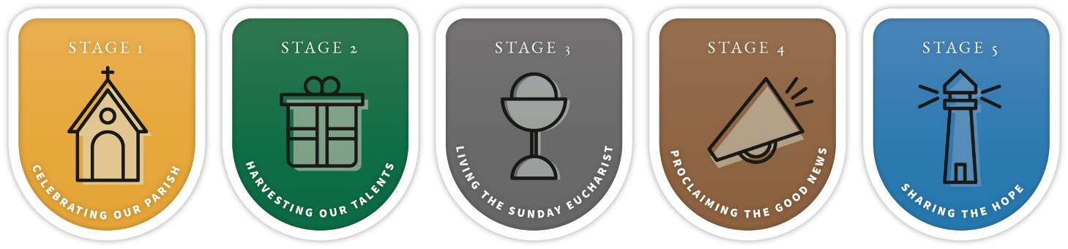

Forming Missionary Disciples - Building Missionary Parishes

