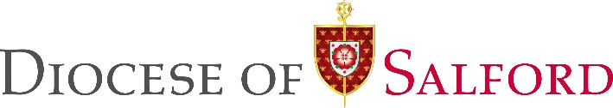

Simple privacy notice for inclusion on parish forms where personal data is being collected.

The following is a simple privacy notice which can be included on forms where personal data is being collected. An example could include information about catechetical programmes (such as First Holy Communion or Confirmation Programmes).

“The personal information about you on this form is being collected in pursuance of the Legitimate Interests of the Diocese in promotion of the Roman Catholic Faith. It is being used to assist with the service of …….., or to assist with the preparation of (explain nature of service).

The information collected about you will be stored securely and not transferred to any third party for general use or marketing purposes and it will be securely deleted or destroyed, no later than 1 month after the event.”

If you have any questions then please contact [insert name of priest or parish administrator]

You can read the full Diocesan Privacy Notice at www.dioceseofsalford.org.uk

