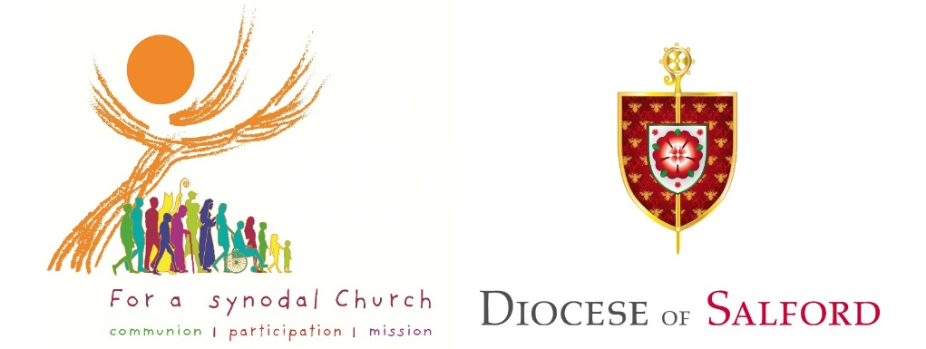

Diocesan Stage of the Universal Synod
Parish Feedback Sheet
A guide for ‘Facilitating a Parish Gathering’ is available at www.dioceseofsalford.org.uk/faith/synod.
Once completed, please email (as a word document or print/scan) to synod@dioceseofsalford.org.uk or post to ‘Synod, Diocese of Salford, Cathedral Centre, 3 Ford Street, M3 6DP’ before 1st March 2022.

Thank you for taking part in this process.

Parish Information (optional)

Parish name & area
Type of Group
Number in Group
Duration of Gathering
Completed By
Email Address
Additional comments

Reflection Questions
- What has been your experience of your parish/community during the Pandemic?
Round 1 of listening (points made/bullet points)

Round 2 of listening (agreed common response)

- How can we best listen to each other, in the Church and in the wider world?
Round 1 of listening (points made/bullet points)

Round 2 of listening (agreed common response)

- How we do we communicate with each other in our groups, parishes, diocese? Do we have the freedom to speak openly in a loving way?
Round 1 of listening (points made/bullet points)

Round 2 of listening (agreed common response)

- In what ways does prayer and the celebration of Mass enable us to encounter Jesus more deeply and empower us in our daily lives?
Round 1 of listening (points made/bullet points)

Round 2 of listening (agreed common response)

- What do you sense the Holy Spirit asking of the Church?
Round 1 of listening (points made/bullet points)

Round 2 of listening (agreed common response)

- Who walks with us on our journey of faith? What persons or groups are marginalised?
Round 1 of listening (points made/bullet points)

Round 2 of listening (agreed common response)

- How can we best share the Good News of Jesus with others? What difference are we currently making?
Round 1 of listening (points made/bullet points)

Round 2 of listening (agreed common response)

- In what ways do our parishes/communities speak to each other and the wider society? How could we do this better?
Round 1 of listening (points made/bullet points)

Round 2 of listening (agreed common response)

- How are we as a community listening to, and enriched by, other Christian denominations and other faiths?
Round 1 of listening (points made/bullet points)

Round 2 of listening (agreed common response)

- In what ways do we take collective responsibility (priest and lay faithful collaboration) for our community? What are the fruits of this collaboration, and what are the obstacles and challenges?
Round 1 of listening (points made/bullet points)

Round 2 of listening (agreed common response)

- How do we discern together the direction in which the Holy Spirit is leading us? How can we develop this shared responsibility together?
Round 1 of listening (points made/bullet points)

Round 2 of listening (agreed common response)

- What support do we need to help us grow as a Church journeying together, listening to each other and the Spirit?
Round 1 of listening (points made/bullet points)

Round 2 of listening (agreed common response)

- Is there anything else you would like to share with us?
Round 1 of listening (points made/bullet points)

Round 2 of listening (agreed common response)

