

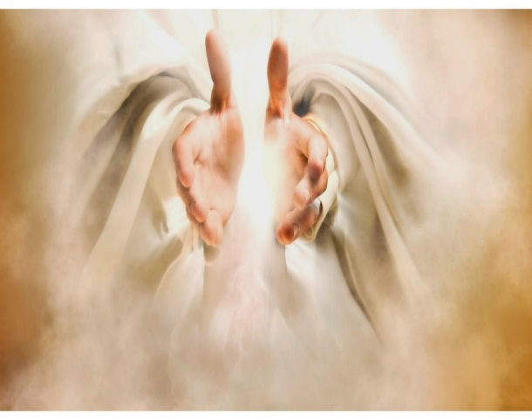

**PRAYER FOR HEALING**

**PRAYER FOR HEALING**



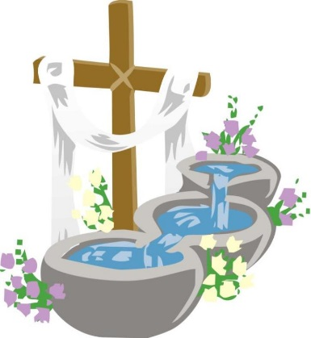

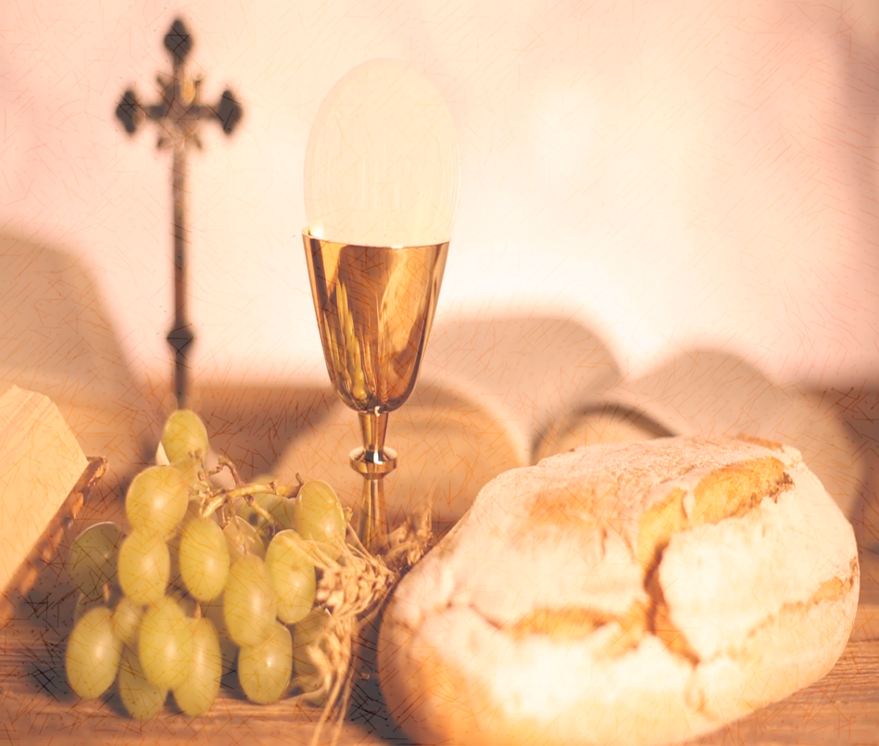

**PRAYER FOR THOSE MAKING THEIR FIRST HOLY COMMUNION**

**PRAYER FOR THE**

**NEWLY BAPTISED**

**Prayer Card FRONT**

*Tip – Print back to back, cut out then laminate*

**Prayer for a NAME of our PARISH**

**My heart holds a prayer that carries you NAME**

**So close to God’s loving heart.**

**I lay out my hope that you’ll know his touch**

**And be healed by the Lord above**

**So I trust in our Abba Father**

**To comfort you when you cry**

**And bless the hands of the medical teams**

**That care for you each day and night.**

**I wish I could be beside you always**

**To hold your hand and pray.**

**So I’m sending my love, my thought and my faith,**

**To be with you my wonderful friend.**

**Prayer for a NAME of our Parish**

**O Holy Spirit please come like a dove**

**Shield and protect now NAME who we love**

**Cover their wounds with Your grace feathered wings, shield them from sorrow, breathe hope songs within**

**Tend with Your goodness the pain**

**that they bear**

**Heal now their sickness with miracle care**

**Carry them high far above till they see Your rainbow of promise, real hope lies ahead**

**I love them so dearly, so help me to be**

**All that you, Jesus,**

**Would give out through me**

**Prayer for a NAME of our PARISH**

**Crucified God, we wear beautiful crosses around our necks, and hang them on our walls. We have made your triumphant sign of suffering decorative, when what it really needs to be is defining.**

**So make us cruciform Lord, in our weekly remembrance of Christ’s death on the cross in our breaking of this bread and taking of this wine.**

**Let us show by the offering of our hearts and hands the depth of our commitment to live for him who died for us.**

**In lives of sacrifice and service, empower our witness to Jesus Christ, whose cross so powerfully proclaims your love. Amen.**

**Prayer for a NAME of our PARISH**

**Name you are taking this step of faith.**

**In obedience to the Lord to be baptised in His precious name, and follow our Master’s call to the rise up with faith in God.**

**Go where he may lead and share God’s love to everyone, and touch them in their need.**

**God pours out his blessings, upon your life today, so you may walk in His abundance, as you commit to Him your way.**

**Keep on trusting in the Lord. No matter what you face. And keep your eyes on Jesus Christ, and live in his sweet grace.**

**Prayer Card BACK**

*Tip – Print back to back, cut out then laminate*





**PRAYER FOR OUR JOURNEY WITH GOD**

**PRAYER FOR A NEWLY MARRIED COUPLE**



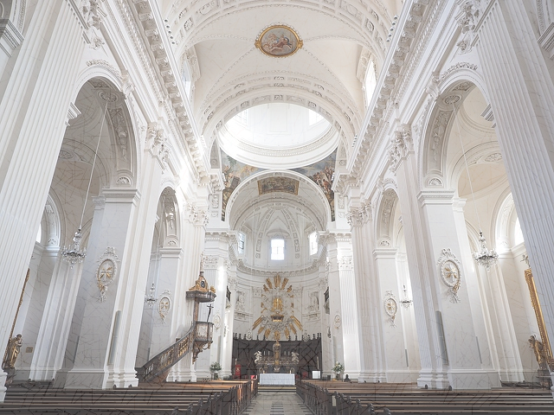****



**PRAYER FOR HOLINESS**

**PRAYER FOR VOCATIONS**

**Prayer Card FRONT**

*Tip – Print back to back, cut out then laminate*

**Prayer for a NAME of our PARISH**

**As John watched Jesus walk by he said, “Look! There is the lamb of God!” The two disciples heard what he said, and followed Jesus. When Jesus turned around and noticed them following Him, He asked them, “What are you looking for?” They said to Him, “Rabbi, where do you stay?” “Come and see”**

**He answered. *John 1:36-39***

**Let us walk together. All of us are on a journey, for each day the Lord reveals Himself to us through others.**

**We cannot love someone we do not know. We cannot freely choose a path unless we understand the consequences of our choice.**

**To follow Christ, to be a Christian, means we may not always be comfortable, accepted or successful in the eyes of the world. It is a commitment, a decision, we must make every day. Come, let us begin.**

**Prayer for a NAME of our PARISH**

**Love is patient, love is kind. It is not jealous, love is not pompous, it is not inflated, it is not rude, it does not seek its own interests, it is not quick-tempered, it does not brood over injury, and it does not rejoice over wrongdoing but rejoices with the truth. It bears all things, believe all things, and endures all things.**

**If there are prophecies, they will be brought to nothing; if tongues, they will cease; if knowledge, it will be brought to nothing. For we know partially and we prophesy partially, but when the perfect comes, the partial will pass away.**

**When I was a child, I used to talk as a child, think like a child; reason as a child; when I became an adult, I put aside childish things. At present we see indistinctly, as in a mirror, but then face to face. At present I know partially; then I shall know fully, as I am fully known. So faith, hope, love remain, these three; but the greatest of these is love.**

**Prayer for a NAME of our PARISH**

**Lord, our God, source of all life, you reveal yourself in the depths of our being drawing us to share in your life and love.**

**Bless each of us as we respond to your Spirit’s invitation to open wide the doors to Christ.**

**Make the doors of our hearts, our homes and communities wide enough to receive all who need human love and fellowship, narrow enough to shut out all envy, prejudice and pride.**

**Let us hasten to welcome the stranger, and so welcome your Son.**

**We make this prayer in his name,**

**Jesus Christ, our Lord.**

**Amen.**

**Prayer for a NAME of our PARISH**

**O Lord, my God, You renew the Church in every age by raising up priests outstanding in holiness, living witnesses of Your unchanging Love, In Your Plan for our salvation You provide shepherds for Your people.**

**Fill the hearts of young men with the spirit of courage and love that they may answer Your call generously. Give parents the grace to encourage vocations in their family by prayer and good example.**

**Raise up worthy priests for Your Altars and ardent, but gentle servants of the Gospel.**

**Give the Church more priests and keep them faithful in their love and service. May many young men choose to serve YOU by devoting themselves to the service of Your people.**

**Prayer Card BACK**

*Tip – Print back to back, cut out then laminate*