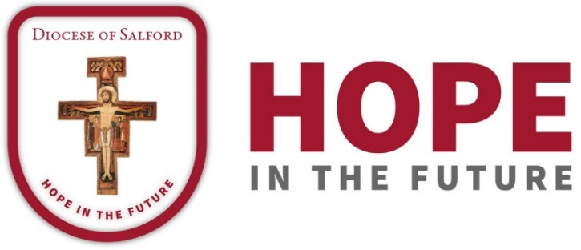

DIOCESAN PRAYER CYCLE
PRAYERS OF THE FAITHFUL

10th/11th August – 26th/27th October 2019

10th/11th August
This weekend we pray for the people of the parishes of St. Mary, Langho, and St. Mary, Osbaldeston, and for Fr. Leo Heakin, their parish priest. We pray for their parish primary schools and for St. Augustine’s High School.

17th/18th August
We pray for the people of the parish of English Martyrs, Whalley, and for Fr. David Yates, their parish priest.

24th/25th August
Let us pray for the people of the parishes of Our Lady of Perpetual Succour and the Holy Family, Blackburn, and for Fr Gerard Barry, their parish priest, their parish primary schools and Our Lady and St. John’s College. We pray for the chaplaincy to the Royal Blackburn Hospital.

31st August/1st September
For the people of the parishes of St. Mary, Bamber Bridge, and Our Lady and St. Gerard, Lostock Hall, for Fr. Mark Harold, Fr. Colin Battell OSB, and Fr. Joe Gee and the Sisters of Our Lady of the Missions. We pray for their parish primary schools and for St. Mary’s College. May they continue to seek ways in which they can work together in our common mission of making Christ present to our world.

7th/8th September
For the people of the parishes of Our Lady and St. Patrick, Walton-le-Dale, and St. Mary and St. John Southworth, Samlesbury, for Fr Philip Nathanael, their parish priest and for its parish primary school

14th-15th September
For the people of the parish of Sacred Heart, Darwen, for Fr. Brian Kealey, their parish priest, and for their parish primary schools.

21st/22nd September
For the people of the parish of the Sacred Heart and St. Anne, Blackburn, and Fr. James McCartney, their parish priest, for the Marist Fathers, and the parish primary school. We pray for the work of THOMAS.

28th/29th September
For the people of the parishes of St. Wilfrid’s, Longridge, SS Peter and Paul, Ribchester, and St. Mary’s, Chipping, and for Fr. Anthony Dutton, their parish priest. We pray for the parish primary schools, for St. Cecilia’s High School and for the work of Lee House.

5th/6th October
For the people of the parish of St. Alban, Blackburn, for Canon Jude Harrison, their parish priest, Fr. Paul Taylor, OMI, and the Franciscan Missionary Sisters of St. Joseph. We pray for the parish primary schools and for St. Mary’s College.

12th/13th October
For the people of the parish of Our Lady of the Valley, Clitheroe, Sabden and Dunsop Bridge, and Canon Paul Brindle, their parish priest. We pray for their parish primary schools and for Clitheroe Hospital.

19th/20th October
For the people of the parish of St. Oscar Romero, Blackburn, Fr. Shaun Braiden, their parish priest, and Fr Francis Kochupaliath, for their parish primary schools and for St. Bede’s High School.

26th/27th October
For the people of the parish of St. Peter, Stonyhurst, and for Fr. Timothy Curtis, SJ, their parish priest. We pray for their parish primary school and for Stonyhurst College.

