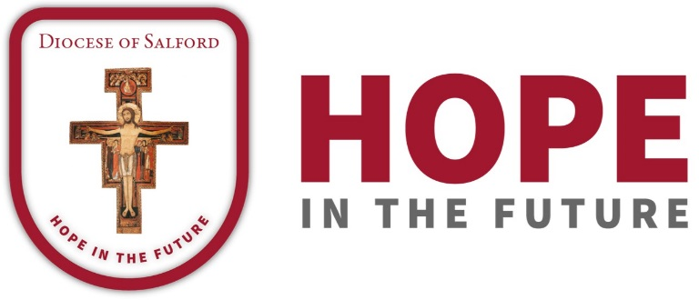

DIOCESAN PRAYER CYCLE
PRAYERS OF THE FAITHFUL

SEASON OF EASTERTIDE 2018

31st March/1st April 2018
Let us pray, this Easter night/day, for the people of the parish of St. Herbert, in Chadderton, with Fr. Peter McKie, their parish priest, and the people of Sacred Heart parish, Darwen, with Fr. Brian Kealey, their parish priest. We pray for their parish primary schools and for Blessed John Henry Newman College, Oldham.
May the parishes of our Diocese shine forth with the light of the Risen Lord.

7th/8th April 2018
We pray for the people of the parishes of St. Wilfrid, Longridge, St. Mary’s, Chipping and Saints Peter and Paul, Ribchester, with Fr. David Chinnery, their parish priest. We pray for their parish primary schools and for St. Cecilia’s High School, Longridge, and for Longridge Community Hospital.
May we know the depths of Divine Mercy we receive in the Eucharist.

14th/15th April 2018
In union with Bishop John and our Diocese we pray for the people of the parishes of St. Mary, Clayton-le-Moors and Our Lady and St. Hubert with St. Wulstan, Great Harwood, and Fr. Anthony Clarke, their parish priest, and for the parish of St. Charles, Rishton, with Fr. Martin Dowd, their parish priest. We pray for their parish primary schools.
May we be witnesses to the Living Lord.

21st/22nd April 2018
In our Diocesan Cycle of Prayer we pray for the people of the parishes of St. Joseph’s, Reddish, with Fr. Philip Caldwell, their parish priest, and Holy Family, Denton, with Fr. Christopher Dawson, their parish priest. We pray for the primary schools that serve these parishes.
We pray that the Lord will raise up in our Diocese men to serve him as priests and as deacons.

28th/29th April 2018
Let us pray for the people of the parishes of St. Mary’s, Eccles, with Fr. Robert Livesey, and the Holy Cross, St. Matthew and St. Gilbert, Eccles, with Fr. Martin Collins. We pray for their parish primary schools and St. Patrick’s College.
May we be rooted always in Jesus, the True Vine, and so produce a rich harvest.

5th/6th May 2018
Let us pray, across our Diocese, for the people of the parish of St. Mary, Bamber Bridge, with Fr. Mark Harold and Fr. Colin Battell, and for the people of the parish of Our Lady of Lourdes and St. Gerard Majella, Lostock Hall, and their parish priest, Fr. Xavier Ho, together with their parish primary schools and St. Mary’s College, Brownedge. We pray for the sisters of Our Lady of the Missions and for St. Catherine’s Hospice.
May the joy of the Lord be our strength.

12th/13th May 2018
We pray, as one Diocese united in prayer, for the people of the parish of St. Stephen’s, Droylsden, and Fr. Bernard Wilson, their parish priest and for the people of the parish of St. Anne’s, Openshaw, and their parish priest, Fr. Chris Lough. We pray for the Presentation Sisters and for the primary schools serving these parishes.
May we all pray for a fresh outpouring of the Holy Spirit.

19th/20th May 2018
In union with Bishop John, let us pray for the people of the parish of the Immaculate Conception, Failsworth, with Fr. Michael Job and Fr. John Adio, and the parishes of Corpus Christi, and Holy Family and Holy Rosary, Oldham, with Fr. Gaspar Oladosu, and for the Sisters of Mercy. We pray for the primary schools serving these parishes.
May the Spirit of the Lord be poured out in abundance upon us.

