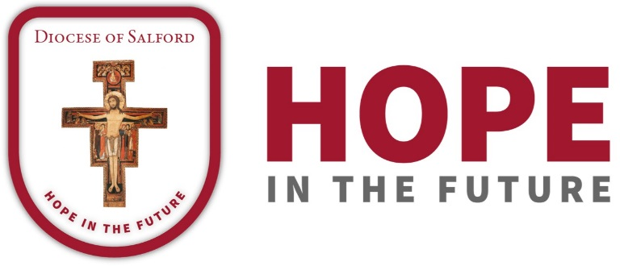

DIOCESAN PRAYER CYCLE
PRAYERS OF THE FAITHFUL

26th/27th May – 30th June/1st July

26th/27th May 2018
On the solemnity of the Most Holy Trinity we pray for the parish of Christ the King, Newton Heath with Canon Alan Denneny and the parishes of Our Lady of Mount Carmel and St John Bosco, Blackley with Fr Philip Brady. We pray for their primary schools.
May God, the Father, Son and Holy Spirit guide us on our Diocesan Journey.
2nd/3rd June 2018
We pray for the parish of Our Lady and St John, Chorlton -cum- Hardy with Fr Patrick McMahon, and the parish of St Ambrose, Chorlton with Fr William Foley. We remember also in our cycle of prayer their primary schools.
May Jesus in the Holy Eucharist enrich our parishes to be the place where we become what we receive.
9th/10th June 2018
As we journey together in Hope as a Diocese we pray for the parishes of St Anne’s, Crumpsall with Fr David Glover, and for the parish of St Clare, Higher Blackley and the Franciscan community. Let us pray for the Good Shepherd Sisters and their life and work. We pray for their primary schools
16th/17th June 2018
As a Diocese united in prayer we pray for the parish of St Bernadette, Withington, with Fr Colin Wright, and the parish of St Bernard, Burnage with Mgr Michael Kujacz, and Fr John Coe. We remember all the young people and staff in their parish primary schools and Loreto High School as well as the Marist Sisters.
On this day for life we pray that our parishes may be beacons of hope promoting the dignity of human life from conception to natural death.
23rd/24th June
In our Journey with Hope in the Future we build firm foundations through prayer. This week let us pray for the parish community of St Chad, Cheetham Hill and the Oratorian community. We pray also for the parish of St. Marie and St. Joseph, Bury, with Fr Francis Wadsworth. We pray also for their parish primary schools, for St. Gabriel’s High School, Bury, and for the chaplaincies to North Manchester General Hospital, Fairfield Hospital and HMP Manchester.
On the Solemnity of the Birthday of St John the Baptist we pray through his intercession that we too may point others to Jesus.
30th June/1st July
In union with Bishop John, let us pray for the people of the parish of St. Michael and St. Bernadatte, Whitefield, and for Canon Steven Parkinson. We pray also for Fr Ian Farrell and the parish of St Joseph’s Longsight and for the Little Sisters of the Poor and those they serve. We pray for their parish primary schools.
May the Lord stay with us on our Journey.

