Walk for Creation
A Guide for Primary Schools

The First Step – An introduction for teachers
Following on from the successful Climate Change walk in the Salford Deanery before COP26 last October, a number of other schools, parishes, and deaneries have expressed an interest in organising a similar ‘Walk for Creation’.
This guide is some simple steps you might want to think about ahead of the walk and some suggested reflections for your stopping points.
These stopping points can be a few metres apart on your school grounds, or you might prefer to make a longer journey - perhaps to your local church.
You may wish to stop at points around your school grounds where there are signs of nature, such as trees or flower beds, or you may wish to create your own prayer focus.
We would love to hear about your walk, so please do get in touch at communications@dioceseofsalford.org.uk
Top Tips for Teachers
Before the walk:
- Decide on the route, length of your walk and any stopping points.
- Complete risk assessments for your walk (an example can be found at https://www.dioceseofsalford.org.uk/services/health-and-safety/)
- You may want to invite your parish priest and family members.
- Identify who will open and lead the reflections (if it’s not you).
After the walk:
Ask your class to reflect on what they've learned and to fill out their Hands of Hope pledges at the back of this book. You might like to put these on display in your school to share ideas. Don't forget to share photos by tagging us on social media!

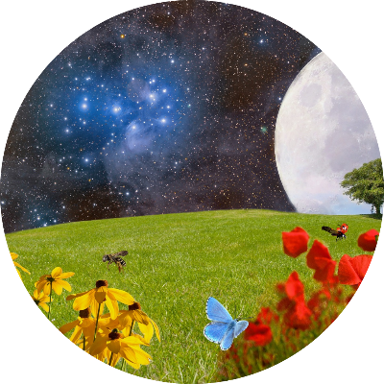
At the Beginning
God made the world and gave life to everything. Everywhere we look, the world is full of beauty. It belongs to everyone on the planet to share.
We start today by making the Sign of the Cross: In the name of the Father, the Son, and the Holy Spirit, Amen.

Reading:
In the beginning, God made heaven and the earth. He made the sun, the moon and the stars in the sky. He made the sea and the land; the trees and flowers; the birds of the air and the fish in the sea. He made dogs, cats, tigers, rabbits, bears, and elephants. He made you. And He made me. God made all the world and everyone in it - and He loves it all very much. Today, we will think about the world God has made and we will do our best to love it too.

Opening prayer:
Our Father, who art in heaven,
Hallowed be thy name.
Thy kingdom come;
Thy will be done On Earth as it is in heaven.
Give us this day our daily bread And forgive us our trespasses,
As we forgive those who trespass against us,
And lead us not into temptation,
But deliver us from evil.
Amen.
Reflection One
For our first stop, we take a moment to think about our wonderful world, remembering that the earth is a gift from God Himself. Pope Francis helps us to remember how lucky we are to live in such a beautiful world and that we must try very hard to look after it.

Time to think:
We stop to think about all the beautiful things in our world.
Listen: What can you hear?
Look around: What can you see?
Remember that God made the tiny flowers and the tall trees. He made all the singing birds and the creepy crawlies that crawl on the ground. God loves the world and He asks us to love it too.

Let us pray:
Creator God,
Your world is a wonderful and beautiful place,
Full of variety, full of wonder, full of life.
Teach us to care for the earth,
And help us to build a world That is filled with your goodness.
Amen.
Prayer from CAFOD

Reflection Two
At our second stop, we focus on people who do not have all the lovely things we have. We pray for people who may be hungry, sick, or have nowhere to sleep.
The Word of God
In the Bible, Jesus tells us a story to teach us more about being kind. This story is called The Good Samaritan. We pause at this stop on our walk to read the story and think about what Jesus might be asking of us:
One day, a man was walking along the road when he suddenly came across a group of robbers. The group hurt the man, and robbed him, leaving him lying injured in the road.
Just then, someone was walking past. He saw the man lying in the road but he carried on walking and didn't help him.
A little while longer, another person came past. They also saw the injured man but they didn't stop either.
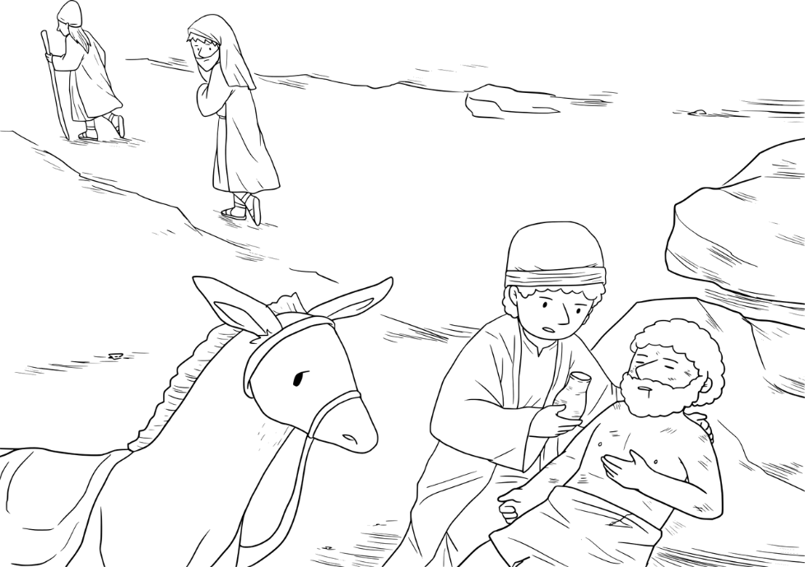
Finally, a third man came along the road - a Samaritan. He saw the injured man in the road and felt sorry for him and wanted to help him.
So, he stopped. He cleaned up the injured man's scratches, bandaged him up, helped him onto his donkey, and took him to a nearby inn, where he took care of him.
The next day, he paid the innkeeper to keep him safe until the man was better.

Time to think:
Do you think it was nice for the first two people to walk past the injured man, without helping?
What do you think about the third man who stopped to help? Do you think he's kind?
What do you think Jesus wanted to teach us with this story?
Do you think Jesus would like us to help other people, like the man in this story?

What does Pope Francis say?
Pope Francis asks us to be kind to other people, especially those who need our help. He reminds us that Jesus Himself was poor; He was hurt and in pain but people were unkind to Him. Pope Francis tells us that whenever we help someone else, we help Jesus.

Time to think
How can we be kind to other people? How can we help look after other people in school or at home? Do you think it's important to treat everyone like our friend?

Let us pray

Loving Father,
Thank you for all our family and friends.
Thank you for all the different people we share our world with.
Please help us to be kind to each other and to look after each other,
Especially the people who need our help the most.
Please help us see the world as one big family.
Amen.

Reflection Three
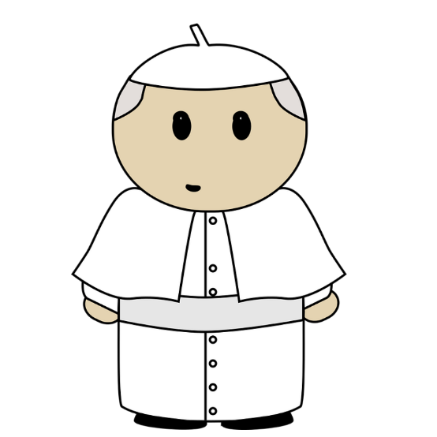
At our third stop, we think about all the different problems our world is facing and how we might be able to help our planet and other people. Pope Francis reminds us that God has a very important job for each of us: He asks us to care for the environment and to care for each other.

Laudato Si'
A few years ago, Pope Francis wrote a letter to every person in the world, asking them to help him care for our planet and the people in it. In his letter, Pope Francis reminds us that the world is a special gift to us from God Himself. He loves the world very much - as well as all the people in it - so we need to look after it and each other. But the world needs our help. Sometimes, we see rubbish lying around or smoke from cars or chimneys going into the sky. It can make our planet and all the animals in it sick. It also causes problems for people in other parts of the world too. A poorly planet can make it harder to grow food or find water. So Pope Francis is asking us to think about some of these problems and to think of little ways we might be able to help.
Time to think
What little things can we do to help our planet?
- Turn off lights when we leave the room
- Always remember to turn off the tap - even while we brush our teeth!
- Never leave rubbish lying around and remember to put it in the bin. Ask your teacher or parents about which bin to use!
- Walking instead of driving is great for our planet! Ask your parents if you can walk more!

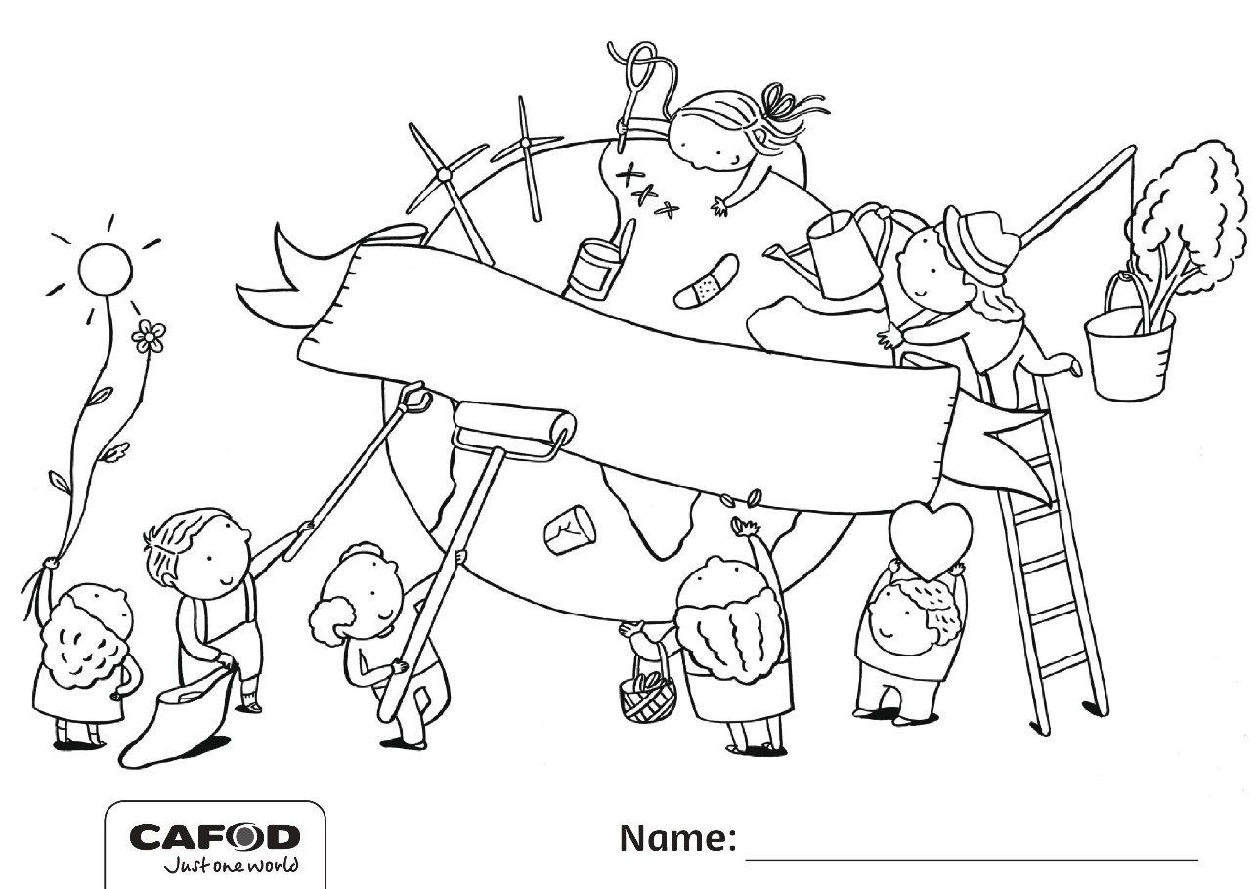

Time to think
What problems are there in our world today?
What can we do to make our world better?
How can we care for our world and the people in it?

Let us pray

Christ has no body but yours,
No hands, no feet on earth but yours,
Yours are the eyes with which He looks Compassion on this world,
Yours are the feet with which He walks to do good,
Yours are the hands, with which He blesses all the world.
Yours are the hands, yours are the feet,
Yours are the eyes, you are His body.
Christ has no body now but yours,
No hands, no feet on earth but yours,
Yours are the eyes with which he looks compassion on this world.
Christ has no body now on earth but yours.
- St. Teresa of Ávila
Hands of Hope
What can you do to care for our planet and other people? Write your ideas in the hand below!

Diocesan Prayer for Our Common Home:
All powerful God, you created all things, and you are present throughout the universe and in every creature,
You embrace with your tender love all that exists.
Pour out upon us the power of your love, so that we may have the strength and courage to protect all life and the beauty of our world, preserving it from pollution and destruction.
Fill us with your peace, that we may live as brothers and sisters, harming no one,
And caring for the Earth, our common home.
Teach us to discover the worth of every creature on this earth,
Let us protect those at risk and in danger,
Encourage us as we seek justice, love and peace. Stay with us each day, with the power of your grace.
Through Christ our Lord,
Amen
