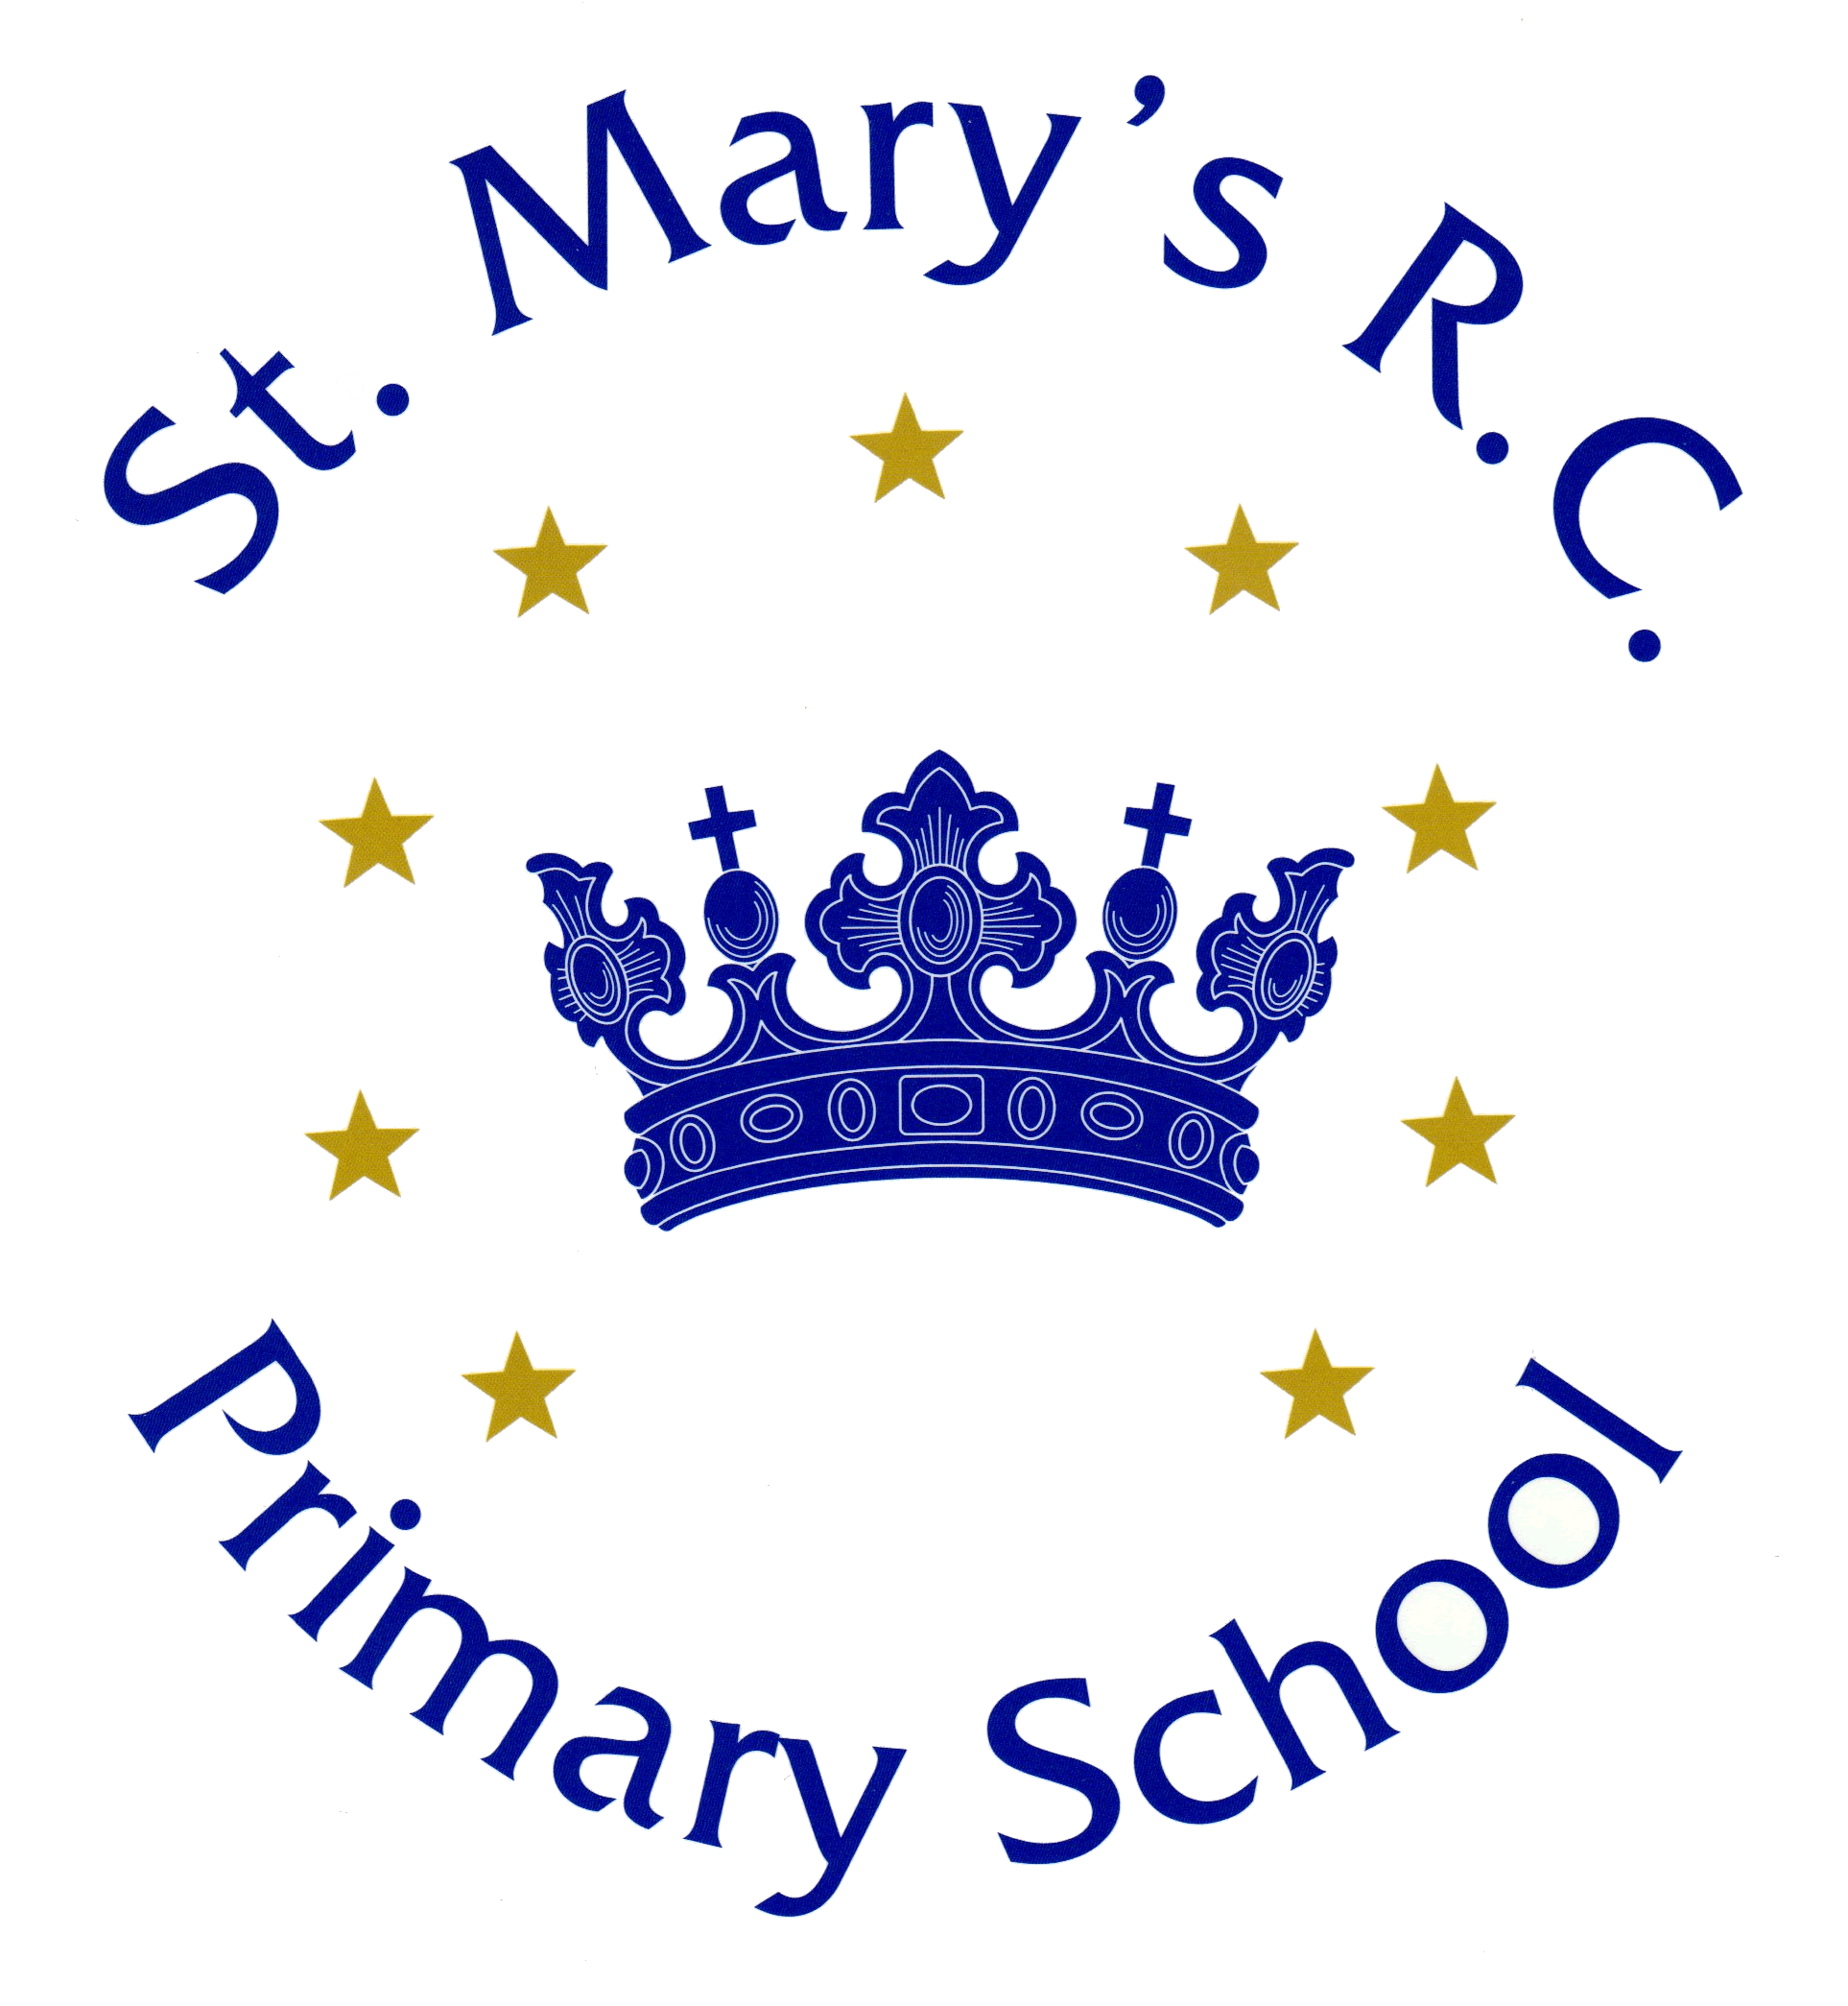 | St. Mary’s R.C. Primary School, Milner Street, Swinton M27 4AS  Tel: 0161 794 4028  Email: stmarysswinton.rcprimaryschool@salford.gov.uk  www.stmarys-swinton.co.uk

School Bursar required for as soon as possible

Grade 3C SCP 26-29 (£29,636- £32,029) pro rata

36 hours per week- term time only + 2 weeks

This is a unique and exciting opportunity to join a successful outstanding and happy Roman Catholic Primary school. Our School Bursar is responsible to the Headteacher and the Governors for the management of the school’s financial affairs and managing a busy office.
The Governors are looking to appoint a friendly, approachable, enthusiastic and well-motivated School Bursar who must be ambitious for our school and dedicated to working collaboratively to achieve the best outcomes for our children. They will be of a sunny and optimistic nature, highly organised, be a committed team player, as well as having great communication skills and a good sense of humour. The successful candidate will show a willingness to follow our school mission statement and abide by the school’s core values.

The successful candidate will be:
- A strategic thinker who can think creatively and problem solve
- Professional, positive and proactive, forming good relationships with all stakeholders
- Skilled at managing systems and people
- Skilled in organisational efficiency and effectiveness
- Enjoy working within a school environment in a vibrant and diverse community

We offer:
- A talented, dedicated and loyal staff
- A supportive SLT with a shared vision
- An effective and supportive Governing Body
- A welcoming and caring catholic ethos
- A school that cares for and nurtures every member of our school family through our School Core Values
- Friendly children who are keen to learn
- A strong commitment to your continuing professional development

Visits to the school are encouraged.
This school is committed to safeguarding and promoting the welfare of children and young people, and expects all staff and volunteers to share in this commitment.

Application forms and details are available on our school website- news and events-new vacancy, to be returned to the Headteacher by post via the school address or by email dee.raynor@salford.gov.uk
Closing date – midday Tuesday 24rd September 2019
Shortlisting date- Wednesday 25th September 2019
Interviews – Friday 27th September 2019

