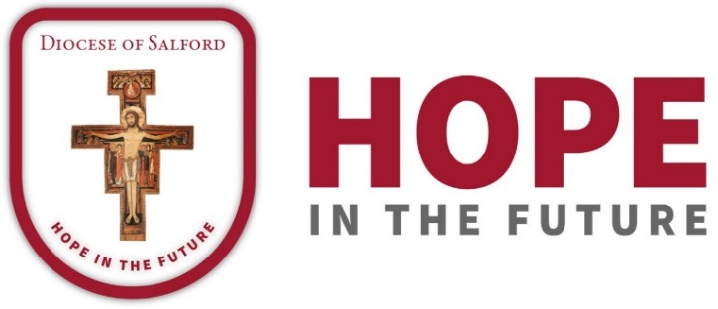

DIOCESAN PRAYER CYCLE
PRAYERS OF THE FAITHFUL

30th/31st March 2019- 18th/19th May 2019

30th/31st March

This weekend we pray for the people of the Cathedral Parish of St. John and the parish of St. Joseph, Ordsall, for Fr. Michael Jones and Fr. Gavin Landers, for Sr. Cecily and Sr. Brenda, for the Franciscan Missionaries of St. Joseph, for the retired priests at Cathedral House, and for the parish primary schools. Let us pray for the success of the renovation work on our Cathedral, that the housing developments in our parishes will build stronger communities and that the presence of Media City will be a channel of good news.

6th/7th April

Let us pray for the people of the parish of the Holy Trinity, Worsley, for Mgr Canon John Dale, for the Franciscan Missionaries of St. Joseph and for the parish primary schools. We pray that St. Ann’s Hospice may be a beacon of God’s healing love.

13th/14th April

We pray for the people of the parish of St. John Paul II, Eccles, with Fr. Martin Collins, for their parish primary schools, and for St. Patrick’s High School. Let us pray that we may walk with the Lord this Holy Week and into the joy of Easter.

20th/21st April

We pray for the people of the parishes of St. Mary, St. Mark and St. Charles, Swinton, with Mgr Paul Smith, for the Franciscan Missionaries of St. Joseph, for their three parish primary schools and St. Ambrose Barlow High School. Let us pray that our parishes may walk ever more closely together in the joy of the Risen Lord.

27th/28th April

Let us pray for the people of the parishes of St. Joseph the Worker and St. Teresa of Avila, Irlam, with Fr Lionel Devaney and Fr. Anthony Clarke, and for their parish primary schools. May this coming year be for them a time of grace and blessing.

4th/5th May

We pray for the people of the parish of Our Lady of Hope, Irlams o’th’Heights and Pendleton, with Canon Michael Cooke, Canon David Ryder and Father Mark Paver, for their parish primary school and for the chaplaincy to the Salford Royal Hospital. Let us pray at the beginning of this month of May that this new parish, under the protection of Our Lady, may radiate Hope to all its member and the wider community.

11th/12th May

Let us pray for the parish of the Three Martyrs, Broughton, with Father David MacFarlane, the Spiritans and Sisters of the Cross and Passion, and their parish primary schools. We pray that the life of the parish may witness to the Risen Lord.

18th/19th May

We pray for the parish of St. James, Pendleton and Weaste, and the Chaplaincy to the University of Salford, with Fr. Frank Mulgrew, and the Mill Hill Missionaries. We pray for the parish primary school and for All Hallows High School. Let us pray that the parish and chaplaincy may be a source of grace for all.

