Opening Prayer – option 2
Opening Hymn
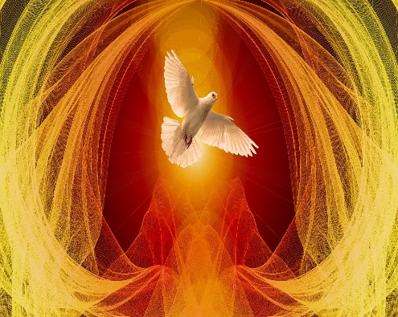
Spirit of the Living God, fall afresh on me.
Spirit of the Living God, fall afresh on me.
Melt me, mould me, fill me, use me.
Spirit of the Living God, fall afresh on me.

Spirit of the Living God, fall afresh on us.
Spirit of the Living God, fall afresh on us.
Melt us, mould us, fill us, use us.
Spirit of the Living God, fall afresh on us.

Reading: Ephesians 3 v 14-21
This then is what I pray, kneeling before the Father, from whom every family whether spiritual or natural takes its name.
Out of his infinite glory, may he give the power through his Spirit for your hidden self to grow strong, so that Christ may live in your hearts through faith, and then, built on love, you will with all the saints, have strength to grasp the breadth and the length, the height and the depth; until knowing the love of Christ , which is beyond all knowledge, you are filled with the utter fullness of God.
Glory be to him whose power working in us, can do infinitely more than we can ask or imagine; glory be to him from generation to generation in the Church and in Christ Jesus for ever and ever.

Pause to listen with your heart.

Sacred Mystery, waiting on the threshold,
You open the gates and beckon me in.

Come! Come! be not wary of what awaits you,
as you enter the unknown terrain
be not doubtful of your ability to grow
from its joys and sorrows.
I am with you. I will be your guide.
I will be your protector. You are never alone.

Sacred mystery, I welcome your unfailing Presence,
And walk with hope into this new life.
(Adapted from Out of the Ordinary Joyce Rupp)

Words of Pope Francis
The Synod offers us the opportunity to become a listening Church, to break out of our routine in order to stop and listen, firstly to the Spirit in adoration and prayer, and then to our brothers and sisters, their hopes, the crises of faith around the world, the need for renewed pastoral life.
Keeping in mind that God’s style is one of closeness, compassion and tenderness, the Synod is also an occasion for the People of God not to be aloof but to become a Church of closeness by her very presence, bandaging wounds and healing broken hearts with the balm of God.

Not another Church but a different Church For this, we need the ever-new breath of God, the Spirit, who sets us free from every form of self-absorption, revives what is moribund, loosens shackles, and spreads joy. “There is no need to create another Church, but to create a different Church,” “For a ‘different Church’, the Pope urged all to invoke the Holy Spirit with greater fervour and frequency and humbly listen to Him.

Pause to reflect quietly on the words of Pope Francis.

Opening Prayer – option 3

Opening Hymn
Holy Spirit of fire flame everlasting, so bright and clear,
Speak this day in our hearts,
lighten our darkness and purge us of fear,
Holy Spirit of fire.

The wind can blow or be still, or water be parched by the sun.
A fire can die into dust: but here the eternal Spirit of God
tells us a new worlds begun.

Holy Spirit of love, strong are the faithful who trust your power.
Love who conquers our will, teach the word of the Gospel of peace,
Holy Spirit of love.

Holy Spirit of God, flame everlasting so bright and clear,
Speak this day in our hearts.
Lighten our darkness and purge us of fear,
Holy Spirit of God.

Reading: James 1 v19 &16-18

Remember this my dear brothers and sisters, be quick to listen and slow to speak. Wherever you find jealousy and ambition, you find disharmony, whereas the wisdom that comes down from above is essentially something pure; it makes for peace and is kindly and considerate; it is full of compassion and shows itself by doing good; not is there any trace of partiality or hypocrisy in it. Peacemakers when they work for peace, sow the seeds which bear fruit in holiness.

Pause to reflect quietly.

Choices
Lord, in this world of mixed and changing values, we ask for others, each other, and for ourselves the wisdom to distinguish between the important and the unimportant, the true and the trivial.
Sometimes we do not know which way to turn. There are many claims on our time, so many demands for our attention.

Life pulls us in so many directions and presents so many possibilities,
so that the very range of choices before us can help to confuse rather then clarify.

It is then that we need you, for yours is the ultimate claim on our lives.
Help us to listen for it in all the other claims that are made on us.

Because we cannot do everything, help us to get our priorities right.
To know what you want us to do now, and what you want us to leave.

And as we seek to be your disciples, help us to see that what we do,
and what we allow your Spirit to do, and everything that happens to us: the foreseen and the unexpected, the delights and trials,
the criticism and praise, the good fortune and grief,
Will shape what we will become. Amen
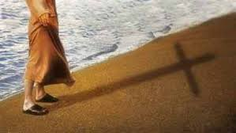
Pause to reflect quietly.

Intercessory Prayers

As we gather for this meeting, fill us with your Spirit of wisdom.

R/ Lord, send out your Spirit to renew the face of the earth.

May we have the wisdom to discern your word and courage to live it.
R/
May we always be courageous in giving witness to our faith.
R/
May we live out fully our Baptismal promises.
R/
May we transform structures which oppress the weak.
R/
Let us pray in the word Jesus taught us, Our Father.

Let us pray.
Almighty and eternal God, in baptism we were reborn in water and the Spirit. Keep alive in us the fire and zeal of the first believers and inspire us to do the works of Jesus, who lives and reigns with you and the Holy Spirit, one God forever and ever. Amen

Opening Prayer – option 4
Opening Hymn

Listen, let your heart keep seeking;
listen to his constant speaking, listen, to the Spirit calling you.
Listen to his inspiration,
listen, to his inspiration, listen to his invitation,
listen to the Spirit calling you.
He’s in the sound of the thunder, in the whisper of the breeze,
He’s in the might of the whirlwind, in the roaring of the seas.

He’s in laughter of children, in the patter of the rain.
Hear him in cries of the suffering, in their moaning and their pain.

He’s in the noise of the city, in the singing of the birds.
And in the night-time the stillness, helps you listen to his word.

Reading: Proverbs 2 v1-6 v 15, 17.
If you take my words to heart, if you set store by my commandments,
tuning your ear to wisdom, and applying your heart to truth:
yes, if your plea is for clear perception, if you cry for discernment, if you look for it as if it were silver, and search for it as for buried treasure, you will then understand what the fear of the Lord is and discover the knowledge of God.
She is beyond the price of pearls, nothing you could covet is her equal. Her ways are delightful ways, all her paths lead to contentment. She is a tree of life for those who hold her fast.

Pause to reflect silently.

TRASNA the crossing place
The pilgrims paused on the ancient stones in the mountain gap.
Behind them stretched the roadway they had travelled.
Already a far journey… was it a lifetime? Ahead, mist hid the track.
Unspoken, the question hovered: Why go on? Is life not short enough?
Why seek to pierce its mystery? Why venture further on strange paths, risking all?
Surely that is a gamble for fools…. or lovers.
Why not return comfortably to the known road? Why be a pilgrim still?
A voice they knew called to them saying:
this is Trasna, the crossing place. Choose!
Go back if you must,
You will find your way easily by yesterday’s fires,
there may be life in the embers yet.
If that is not your deep desire, stand still. Lay down your load.
Take your life firmly in your two hands,
[Gently…. you are trusted with something precious]
while you search your heart’s yearnings:
What am I seeking? What is my quest?
When your star rises deep within, Trust yourself to its leading.

You will have the light for first steps
This is Trasna, the crossing place. Choose!
This is Trasna, the crossing place. Come!

Raphael Consedine

Pause to reflect silently.

Let us pray together
Come Holy Spirit, fill the hearts of your faithful
and kindle in them the fire of your love.
Send forth your Spirit and they shall be created.
And You shall renew the face of the earth.
O, God, who by the light of the Holy Spirit,
has instructed the hearts of the faithful,
grant that by the same Holy Spirit
we may be truly wise and ever rejoice in
His consolations, through Christ Our Lord. Amen

