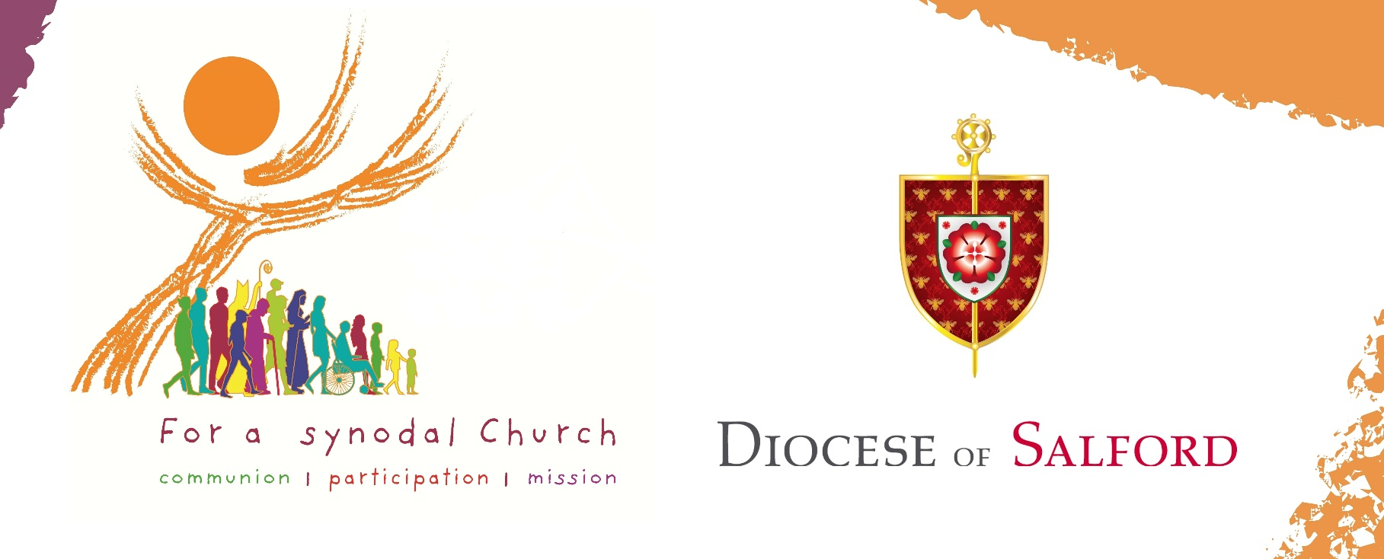
Synod Resources
We have produced several resources for the Diocesan Stage of the Universal Synod, entitled ‘For a Synodal Church: Communion, Participation, Mission’.
Parishes are encouraged to make copies/distribute electronically of any of these resources. Please share these on your parish website, newsletter, noticeboard, and social media and with your associated schools. We want to hear from as many people as possible. If you require printed copies of these resources, please request these by emailing synod@dioceseofsalford.org.uk. Please remember the Synod in your prayers.
The following resources are available at www.dioceseofsalford.org.uk/faith/synod.

- Bishop John’s Pastoral Letter
- Reflection Questions based on the themes of the Synod
- Online Submissions Form
- Paper Submissions Form
- Facilitating a Parish Gathering Guide to encourage prayerful listening
- Parish Feedback Sheet to make a collective response
- Reflection Questions for children/young people
- Poster for parish noticeboards to encourage engagement

Suggested Newsletter Insert
Pope Francis has called a Universal Synod which is taking place in every Catholic diocese across the world. The Synod is themed: “For a Synodal Church: Communion, Participation, and Mission”. We want to hear from as many people as possible, those involved in the church and those who are not. You can take part by completing an online submission using the QR code or following this link www.surveymonkey.co.uk/r/3D3FXJ2. Please share this link with family and friends. We have until 1st March 2022 to make our submissions then, after national and continental gatherings, the Synod of Bishops will gather in Rome in 2023 to reflect on what has been heard. Please remember the Synod in your prayers. Your contribution is invaluable and will make a considerable difference to the future of the Church in our diocese and across the world.

