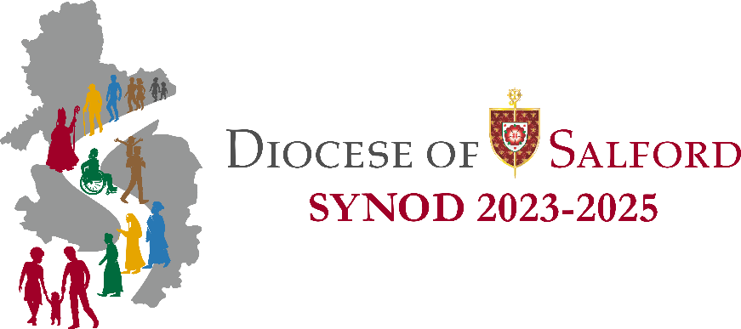

Suggested Newsletter Insert (edit as required)

Diocesan Synod – ‘The Big Listen’

A Diocesan Synod is an important event in the life of a Diocese in which Bishop, priests and lay-people come together in a spirit of prayer to discern together what God is asking of His Church in our Diocese and will help us to live out our calling to be Missionary Disciples.

We have arranged a listening session in our parish as part of ‘The Big Listen’ for our Diocesan Synod. This will take place on (date) at (time) at (location). All are welcome to attend. You may wish to invite family and friends to attend too.

This will be an opportunity to respond to four questions which will help shape the future of the Church in our Diocese.

If you are planning on attending, please write your name on the list at the back of church.

You can also respond via the online form at www.dioceseofsalford.org.uk/faith/synod/.

If you have any questions, please speak to (Synod Member names).

