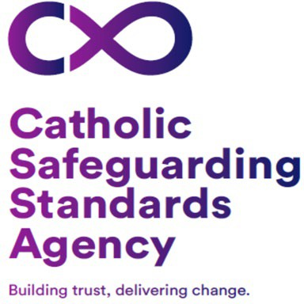

Volunteer Registration Form

VOLUNTEER ROLE

Name of Parish and Churches:
Role(s) you are volunteering for:
PERSONAL INFORMATION

Title
First Name
Surname
Address
Postcode
Preferred telephone number

Email address

VOLUNTEERS FROM OUTSIDE OF THE UK

If you are from outside the UK, you will need to check that your visa allows you to volunteer. Individuals who are asylum seekers, with refugee status or who have exceptional leave to remain can volunteer.

The UK Borders and Immigration Agency should be contacted if there is any uncertainty about permission to volunteer in the UK.
Are you permitted to volunteer in England and Wales? Please tick

Yes
No

As a volunteer of The Diocese of Salford we will from time to time contact you in relation to your roles for training and monitoring purposes, by signing this form you are giving your consent for us to contact you for this purpose.

We would also like to contact you on occasions to inform you of events within the Diocese such as celebratory masses, deanery events, pilgrimages etc.
Do you consent for us to contact you for this purpose? Please tick

Yes
No

DECLARATION
I understand that providing misleading or false information may disqualify me from volunteering.

Signature: Date:

